Report on Monitoring and Assessment: Ukraine, 2020

1. General Information

1.1 Number of cruises performed for monitoring and assessment of pollution in 2020

UkrSCES performed one cruise for monitoring and assessment of pollution of the Black Sea in 2020, and investigated the opened sea area close to Danube Delta. The expedition was performed in August 2020.
Also, in the Report are included results and investigation of the quality of marine waters, bottom sediments and biota in samples which was taking by specialists of monitoring station Odessa National University in marine area near island Zmeinyi.

1.2 Number of stations (sampling points, maps)
The existing stations network of the ecological monitoring in 2020 included 12 stations in the aria close to Danube Delta. Description of these stations is presented in Table 1.
Locations of the stations are presented in Figure 1.

Table 1 - BSIMAP Stations in the aria close to Danube Delta in 2020
No St. | Name  St. | Latitude | Longitude | Location | Performer
Danube delta (August 2020)
1 | 6 | 45°20,980' | 029º51,865' | Danube delta | UkrSCES
2 | 10-2 | 45°19,027' | 029º52,472' | Danube delta | UkrSCES
3 | 10-3 | 45°18,836' | 029º52,158' | Danube delta | UkrSCES
4 | 10 | 45°19,189' | 029º51,989' | Danube delta | UkrSCES
5 | 10-4 | 45°19,202 | 029º51,393' | Danube delta | UkrSCES
6 | 17 | 45°15,113' | 029°51,531' | Danube delta | UkrSCES
7 | 18 | 45°16,407' | 029º49,333' | Danube delta | UkrSCES
8 | 19 | 45°17,570' | 029º47,672' | Danube delta | UkrSCES
9 | 8 | 45°19,322' | 029º47,787' | Danube delta | UkrSCES
10 | 7-2 | 45°19,713' | 029º47,212' | Danube delta | UkrSCES
11 | 7-1 | 45°20,130' | 029º46,419' | Danube delta | UkrSCES
12 | 7 | 45°20,305' | 029º45,885' | Danube delta | UkrSCES
Island Zmeinyi 2020
1 |  | 45.2575 | 30.2050 | NWS Black Sea | ONU, UkrSCES

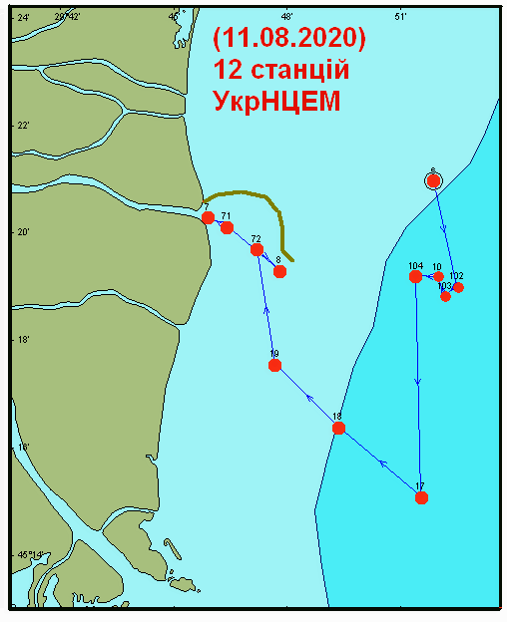
Figure 1 - Location of monitoring stations in the Danube Delta area (11 August 2020)

At each station, water sampling was performed for analysis for hydrochemical parameters from surface and bottom horizons and bottom sediment sampling for chemical-analytical studies on the content of pollutants and granulometric analysis.
1.3 List of monitored parameters

List of monitoring parameters and number of performed samples in comparison with 2018 are presented in Table 2.

Table 2 - Samples numbers of Regional Ukrainian Monitoring Data in 2020/2019
Parameter | Samples numbers  (2020/2019) |  | Parameter | Samples numbers  (2020/2019) | Parameter | Samples numbers  (2020/2019)
Hydrochemicals (water) |  |  | Metals (water) |  | PAHs (water&bs)
Temperature | 62/255 |  | Fe | 24/88 | Naphthalene | 24/90 12/46
Salinity | 62/203 |  | Mn | 0/0 | Acenaphthylene | 24/90 12/46
pH | 62/211 |  | Zn | 24/88 | Fluorene | 24/90 12/46
O₂ | 48/162 |  | Co | 24/88 | Acenaphthene | 24/90 12/46
TSS | 86/48 |  | As | 24/88 | Phenanthrene | 24/90 12/46
Transparency | 24/65 |  | Hg | 24/88 | Anthracene | 24/90 12/46
BOD5 | 0/38 |  | Cu | 24/88 | Fluoranthene | 24/90 12/46
TOC | 24/94 |  | Cd | 24/88 | Pyrene | 24/90 12/46
H₂S | 0/60 |  | Pb | 24/88 | Benzo[a]antracene | 24/90 12/46
P(PO₄) | 62/211 |  | Ni | 24/88 | Chrysene | 24/90 12/46
P_{total} | 62/197 |  | Cr | 24/88 | Benzo(b)fluoranthene | 24/90 12/46
N (NH₄) | 62/211 |  | Al | 0/0 | Benzo(k)fluoranthene | 24/90 12/46
N (NO₂) | 62/211 |  | Other organic pollutants  (water) |  | Benzo[a]pyrene | 24/90 12/46
N (NO₃) | 62/200 |  | Phenols | 0/0 | Dibenzo[a,h]anthracene | 24/90 12/46
N_{total} | 62/200 |  | Detergents | 0/0 | Indeno(1,2,3-c,d)pyrene | 24/90 12/46
SiO₄ | 24/167 |  | TPHs | 0/0 | Benzo(ghi)perylene | 24/90 12/46
Chlororganic pesticides (water&bs) |  |  | PCBs total (water&bs) |  | Metals (bs*)
DDT |  | 24/91 12/49 | Ar1254 | 24/91 12/49 | Zn | 12/49
DDD |  | 24/91 12/49 | Ar1260 | 24/91 12/49 | Co | 12/49
DDE |  | 24/91 12/49 | PCB (21 ind.) | 23/29 23/29 | As | 12/49
Lindane |  | 24/91 12/49 |  |  | Hg | 12/49
α-HCH | 24/91 12/49 |  |  |  | Cu | 12/49
β-HCH | 24/91 12/49 |  |  |  | Cd | 12/49
HCB | 24/91 12/49 |  | Other organic pollutants (bs) |  | Pb | 12/49
Heptachlor | 24/91 12/49 |  | Phenols | 12/46 | Ni | 12/49
Aldrin | 24/91 12/49 |  | TPHs | 12/24 | Al | 12/49
Dieldrin | 24/91 12/49 |  | TOC | 0/0 | Fe | 12/49
Endrin | 0/0 0/0 |  |  |  | Cr | 12/49
* bs – bottom sediments

1.4 National institutions (laboratories) involved
Two institutions are involved in the Ukrainian monitoring system:
- UkrSCES - the Ukrainian Scientific Centre of Ecology of the Sea, Ministry of the Environment Protection (Department of Analytical Research and Organization of Monitoring, head Yuriy Denga)
- Odessa National I.I. Mechnikov University (Regional Centre for Environmental Monitoring and Ecological Studies, head Vladimir Medinets).

1.5 Data were reported to the Ministry of the Ecology and Natural Resources of Ukraine, Ministry of Transport of Ukraine and Permanent Secretariat of the BSC.

1.6 Financing assured by Ministry of the Ecology and Natural Resources of Ukraine and Ministry of Transport of Ukraine.

1.7 Size of funding 50 000 EURO from the Ministry of the Ecology and National Resources and 25 000 EURO from Ministry of Transport.

1.8 QA/QC – how is organized in the involved laboratories
The two laboratories: department of analytical research of UkrSCES and Regional Centre for Environmental Monitoring and Ecological Studies of Odessa National I.I. Mechnikov University which are involved in the international marine monitoring system.

Summary of quality control procedures routinely employed within the laboratory:

- Use of high quality analytical standards for instrument calibration.
- Use of high quality glassware, acids and other reagent and equipment.
- Routine calibration and adjustments of AAS and maintains of continuous records of these calibrations.
- Routine performance tests including complete procedural blank analyses and spikes.
- Use of certified reference material and performance of quality control chart.
- Use of replicate samples.
- Participation in Proficiency testing exercises

1.9 Names of authors of the annual report provided and names of those providing data:

Y. Denga, V. Komorin, S. Kovalishina, V. Ukrainsky, Y. Oleinik, M. Grandova, V. Medinets, O. Miasnikova, O. Leposhkin, A. Tityapkin

1.10 Participation in international conferences, seminars and meetings in 2020:

- Participation in ZOOM - meeting of the consortium "BRIDGE", March 17-18, 2020.
- Participation in ZOOM - meeting of the project Anemone BSB319 on benthic organisms, which was organized by the Institute of Oceanology of the Bulgarian Academy (partner 3 of the project Anemone BSB319), April 3, 2020.
- Participation in ZOOM - meeting of the project Anemone BSB319 on phytoplankton, macrozooplankton and mesozooplacton, which was organized by the Institute of Oceanology of the Bulgarian Academy of Sciences, April 3, 2020.
- Participation in ZOOM - a meeting of the Anemone BSB319 project, which was organized by the project applicant on the problems of the so-called "Hot Spots" on April 22, 2020.
- Participation in the regional meeting of EMODnet on chemistry - Black Sea - June 19, 2020.
- Participation in the online meeting of the leaders of the working group "BRIDGE", June 26, 2020.
- Participation in the online meeting EASME / EMFF / 2018 / 1.2.1.5 / 01 / SI2.806725 - Advisory Board MARSPLAN-BS II, July 9, 2020.
- Online with ZOOM platform The International Conference "Environmental Toxicants in Freshwater and Marine Ecosystems in the Black Sea Basin" (Kavala, Greece) 8-11 September 2020.
- Participation in the Turkish National Black Sea Seminar on Strategic Research and Innovation Programs for the Black Sea (SPDICM), September 16, 2020.
- Participation in Black Sea CONNECT - 2nd meeting of the Steering Committee, September 18, 2020.
- Online with ZOOM platform the International Conference “Environmental Challenges in the Black Sea Basin: Impact on Human Health” at Galati, Romania, 23-25 September 2020.
- Participation in the annual meeting of EMODnet Biology, September 24, 2020.
- Participation in the meeting of young Black Sea ambassadors with national mentors - September 29, 2020.
- Online with ZOOM platform The International Conference “EU integration and management of the Dniester river basin”, October 8-9, 2020. Chisinau, Moldova.
- Participation in the National Online Seminar of Ukraine on Strategic Research and Innovation Programs for the Black Sea (SPDICM) within the Black Sea Connect project, October 15, 2020.
- Participation in the All-Ukrainian Conference "European Integration of Environmental Policy of Ukraine", Odessa, Odessa State Ecological University, October 21-23, 2020.
- Participation in the final plenary web meeting of the SeaDataCloud project on October 29-30, 2020.
- Participation in the extraordinary meeting of the Black Sea River Basin Council, Berezivka, November 13, 2020.
- Participation in the work of the IODE Steering Group for OBIS (SG-OBIS), ninth session, 17 - 20 November 2020
- Participation in the 8th session of the Internet meeting of the Steering Committee of the Black Sea Oceanographic Data and Information Project (ODINBLACKSEA), December 9-10, 2020.

1.11 Publications in 2019

- Гончаров, О. Ю., Корнілов, М. В. Дослідження можливого забруднення пестицидами та походження «дустового» запаху Хаджибейського лиману: Євроінтеграція екологічної політики України, Одеса, Одеський державний екологічний університет, 2020. C. 17–21.
- Гончаров, О. Ю., Янчук, Д. Л. Технологія підготовки забрудненої комунальними стоками води Хаджибейського лиману для компенсації водного дефіциту Куяльницького лиману: Євроінтеграція екологічної політики України, Одеса, Одеський державний екологічний університет, 20. C. 26–32.
- Гончаров, О. Ю., Карпенко, А. А. Поповнення Куяльницького лиману водою р. Дністер за допомогою системи зрошення. Попередні обґрунтування: Євроінтеграція екологічної політики України, Одеса, Одеський державний екологічний університет, 20. C. 22–25.
- Зотов А. Б. Грандова М. О. Зотова О. В. Теренько Г. В. Порівняння структурної організації угруповань фітопланктону українського шельфу й відкритих вод Чорного моря навесні 2016 року //Морський екологічний журнал. – 2020. – №. 2. – С. 22-30.
- Коморін В. М., Диханов Ю. М., Большаков В. М., Попов Ю. І., Мельник Є. А., Савіних-Пальцева Л. В. Гідрологічна структура вод протоки Дрейка за експедиційними даними в грудні 2018 року // УАЖ. 2020. № 1. С. 29-40.
- М.В. Набокин. Mноголетние изменения в зоопланктоне дельты Днестра // Material the International Conference “EU integration and management of the Dniester river basin”, October 8-9, 2020. Chisinau, Moldova - С.236-240.
- Савенко О. Перший досвід фотоідентифікаційних досліджень горбатих китів на станції "Академік Вернадський" (Західна Антарктида). Морський екологічний журнал. Проходить рецензування.

- В. Украинский, С. Ковалишина, Ю. Деньга «Содержание полициклических ароматических углеводородов в воде и донных отложениях в низовье реки Днестр, 2019 г.»//Material the International Conference “EU integration and management of the Dniester river basin”, October 8-9, 2020. Chisinau, Moldova - с.326-331.
- Унрод В. І., Олейнік Ю. В., Третьяк І. П., Осипенкова І.І. До питання щодо переробки полімерних відходів, забруднюючих Чорне море // Modern science: problems and innovations. Abstracts of the 6th International scientific and practical conference. SSPG Publish. Stockholm, Sweden. 2020. Pp. 164-169. URL : https://sci-conf.com.ua/vi-mezhdunarodnaya-nauchno-prakticheskaya-konferentsiya-modern-science-problems-and-innovations-23-25-avgusta-2020-goda-stokgolm-shvetsiya-arhiv/
- Т.А. Чужекова, С.П. Ковалишина К обзору биологических индикаторов изменения климата в пресных водах, на примере макрозообентоса // Material the International Conference “EU integration and management of the Dniester river basin”, October 8-9, 2020. Chisinau, Moldova - С.355-358.
- Харитонова Ю.В., Набокін М.В., Дядичко В.Г. Зоопланктон відкритої частини Чорного моря в 2016–2019 роках та оцінка якості водного середовища за його показниками // Науково-практичний журнал «Екологічні науки» № 2(29). Т. 2, 2020 – 87 -94 С.
- Ben Chehida, Y., Thumloup, J., Vishnyakova, K., Gol’din, P., Fontaine, M C. 2020. Genetic homogeneity in the face of morphological heterogeneity in the harbor porpoise from the Black Sea and adjacent waters (Phocoena phocoena relicta). Heredity 124(3): 469–484.
- Davydenko, S., Mörs, T., Gol’din, P. 2020. A small whale reveals diversity of the Eocene cetacean fauna of Antarctica. Antarctic Science doi:10.1017/S0954102020000516
- Gol’din, P., Haiduc, B. S., Kovalchuk, O., Górka, M., Otryazhyi, P., Brânzilă, M., Păun, E. I., Barkaszi, Z., Ţibuleac, P., Răţoi, B. G. 2020. The Volhynian (late Middle Miocene) marine fishes and mammals as proxies for the onset of the Eastern Paratethys re-colonisation by vertebrate fauna. Palaeontologia Electronica 23(3):a43. https://doi.org/10.26879/1091
- Linetskii, B. (2020). Donacilla cornea (Poli, 1791) (Bivalvia: Venerida: Mesodesmatidae) in the northern Black Sea: new distribution records, shell size and colouration. // Folia Malacologica, - 210-215. - https://doi.org/10.12657/folmal.028.014
- Linetskii, B., Son, M. O., Koshelev, A. V (2020) Contribution to the knowledge on supralittoral macroinvertebrates of the northwestern Black Sea. // Ecologica Montenegrina, 34: 8-19. - https://doi.org/10.37828/em.2020.34.2.
- Kharytonova Y. V., Nabokin M. V. ZOOPLANKTON OF THE NORT-WESTER PART OF THE BLACK SEA IN 2016–2019 AND ASSESSMENT OF THE QUALITY OF THE ENVIROMENT BY ITS INDICATORS //Publishing House “Baltija Publishing”. – 2020. – pp. 683-698 (Розділ в міжнародній монографії).
- Maria Grandova «Changes in phytoplankton community of lower Dniester in 2018-2019» //Material the International Conference “EU integration and management of the Dniester river basin”, October 8-9, 2020. Chisinau, Moldova - с.44-51.
- Shurda K. E. Basic risk assessment methods // Annali d’Italia. 2020 (11). Vol. 2. Р. 50-53.
- Pogojeva, M., González-Fernández, D., Hanke, G., Machitadze, N., Kotelnikova, Y., Tretiak, I., Savenko, O., Gelashvili, N. Bilashvili, K., Kulagin, D., Fedorov, A. 2020. Cetaceans and marine litter in the Black Sea. In: Marine Litter in the Black Sea. In: Aytan et al. (eds). Marine Litter in the Black Sea. Turkish Marine Research Foundation (TUDAV) Publication No: 56, Istanbul, Turkey, 161–171.
- González-Fernández, D., Pogojeva, M., Hanke, G., Machitadze, N., Kotelnikova, Y., Tretiak, I., Savenko, O., Gelashvili, N., Bilashvili, K., Kulagin, D., Fedorov, A., Çağan Şenyiğit, M., Aytan, Ü. 2020. Anthropogenic litter input through rivers in the Black Sea. In: Aytan et al. (eds). Marine Litter in the Black Sea. Turkish Marine Research Foundation (TUDAV) Publication No: 56, Istanbul, Turkey, 183–192.
- Savenko, O. The first record of a piebald common bottlenose dolphin (Tursiops truncatus) in coastal waters of the north-western Black Sea. Theriologia Ukrainica. Прийнято до друку у томі № 19 (2020 р.). Посилання на анонс випуску: http://terioshkola.org.ua/ua/library/pts19-dama.htm.
- Ukrainskiy Vladimir, Svitlana Kovalyshyna, Yuriy Denga, Elena Zubcov, Nina Bagrin, Nadia Andreev, Victor Ciornea, Vladimir Kolosov, Antoaneta Ene. Study of metals in water, suspensions and sediments in the lower part of the Dniester River during 2019 // Abstracts of the International Conference ”Environmental Challenges in the Black Sea Basin: Impact on Human Health” Galati, Romania, September 23-26, 2020 - р.11-12

2 State of the Environment

Introduction
The system of marine environmental monitoring in 2020 was aimed at the study of the main environmental problems of the Black Sea - eutrophication of waters and the chemical pollution of the marine environment.
Sampling and analysis of sea water samples and bottom sediments were carried on board of the ship.
Directly in expedition conditions conducted a measurement of transparency of sea waters, as well as temperature and salinity from the surface to the bottom and carried out analysis of sea water samples for determination of dissolved oxygen, pH, ammonia, phosphate and nitrite nitrogen concentrations.
Carry out sampling and conservation of seawater samples by formalin for analysis of the number and species composition of phytoplankton.
A zooplankton catches by Jedi net.
At the station of sampling of the bottom sediment was carried gathering and preservation by formalin benthic organisms (meiobenthos, macrozoobenthos and microphytobenthos).
Carry out sampling of seawater from the surface horizon for the analysis of photosynthetic pigments.
In the laboratories of the Centre was performed:

- Scientific analysis of meteorological conditions and hydro physical regime of the study areas.
- Chemical analysis of seawater samples for determination of suspended matter (TSS), nitrate, total nitrogen and phosphorus.
- Analysis of sea waters, bottom sediments and biota samples for determination of priority pollutants (TPHs, Corg., Phenols, OCPs, PCBs, PAHs and Trace metals).
- Granulometric analysis of bottom sediments.
- Determination of photosynthetic pigments (chlorophyll a, b, c, feofityn and carotenoids).
- Analysis of the number and species composition of phytoplankton in seawater samples.
- The study of species composition and biomass of zooplankton.
- Study of the number and species composition of benthic communities (macrozoobenthos, macrophytobenthos and microphytobenthos, meiobenthos).

Analysis of the level of pollution in the marine environment was implemented compared with current standards of maximum allowable concentrations (MAC), adopted in Ukraine and in the European Union.
For evaluation of the integral quality of sea water and sediment was used developed in UkrSCES in the 2009 draft "Environmental quality standards of the marine environment".

  - Material and methods

Main equipment:

- GC/MS Agilent
- GC with capillary column and ECD, “Agilent”
- Graphite Furnace AAS “ZeeNit”
- Flame AAS “Spectr-AA-220” – “Varian”
- IR Fourier Spectrophotometers
- UV-VIS spectrophotometer for determination of BOD-5 and COD
- pH-meters: “pH-530”
- laboratory balances:
  - “BR110D”, BR 211D, both “Sartorius” and E 04130 – “OXAUS”

Danube delta area

During 2020 UkrSCES performed 1 expedition according Programme of marine environmental monitoring of the deep-water navigation channel of the Danube - Black Sea (via arm Bystriy).
Expeditionary study conducted in spring (August) 2020.

2.2 Hydrophysical characteristic of the marine part of the Danube Delta in August 2020

To elucidate the most general characteristics of the ecological state of waters in the significantly larger waters of the north-western shelf (NWS) of the Black Sea, satellite data on the distribution of surface water temperature (Fig. 1.2 a) and chlorophyll-a (Fig. 1.2 b) are obtained synchronously with the performance of marine works. The surface temperature of water on most of the shelf varied between 25-26 °C and only in a small area in the northern part of the Odessa basin and in the Danube region, south of the Kiliya delta, it was higher by 0,5-1,0 °C.
The distribution of chlorophyll-a (Fig. 1.2 b) shows the presence of relatively low concentrations in the Dnieper area (3-7 mg/m³). Perhaps the concentrations were higher, but the data on the area, unfortunately, are incomplete. Higher concentrations (10-12 mg/m³) are observed in the narrow coastal zone in the Kili section of the delta, which further expands to the south as it accumulates and spreads mainly on south of the Danube runoff.

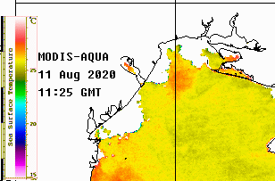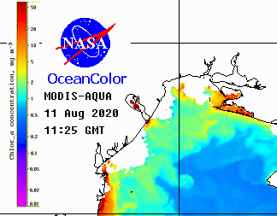
Figure 1.2 - Distribution of water temperature (a) and chlorophyll-a (b) in the surface layer of the north-western shelf (NWS) of the Black Sea according to the satellite "MODIS" 11.08.2020

Data and instrumental observations of surface water temperature (Fig. 1.3 a) show that in the bar area of the navigable mouth Bystriy water temperature was 25,2-25,9 °C and was in the range of 24,2-25,0 °C in open eastern areas of the landfill. The temperature of the bottom waters was slightly below the surface characteristics in shallow water (0,3-0,7 °C) and was slightly lower (on average by 0,8-1,0 °C) in deeper areas (Fig. 1.3 b).

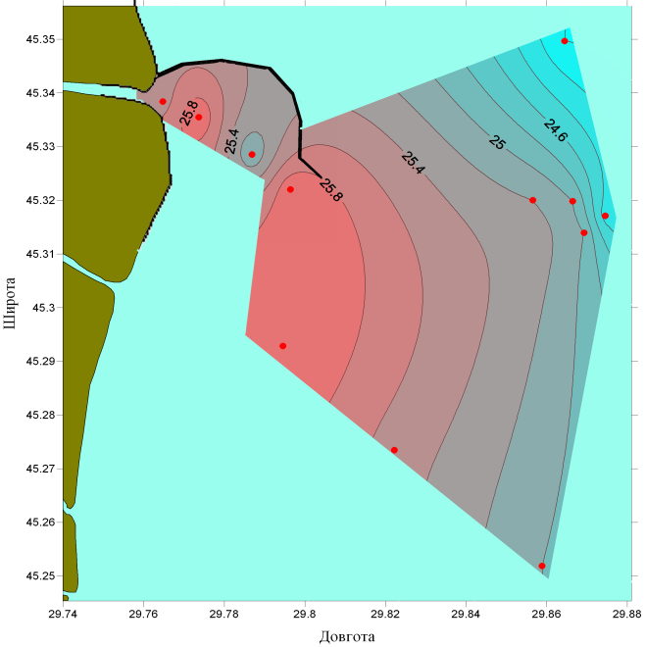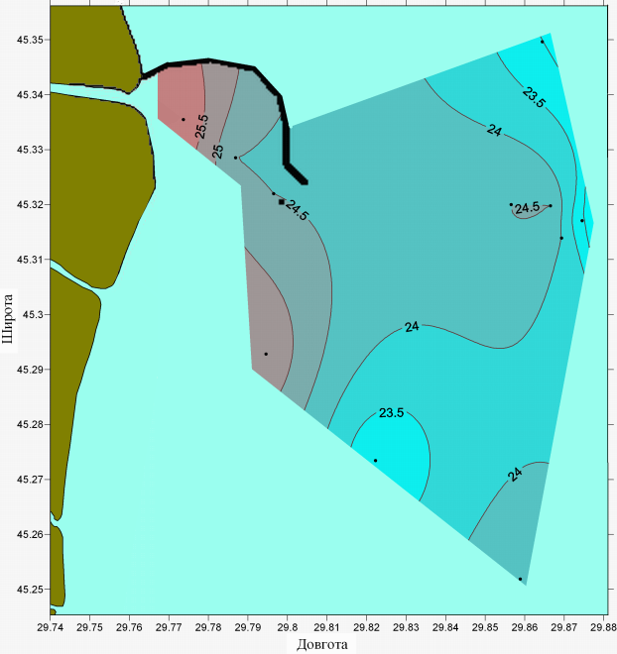
a b
Figure 1.3 - Distribution of water temperature (° C) on the surface (a) and bottom (b) horizons
at the Danube landfill, August 11, 2020

The salinity of the waters at the landfill gradually increased with distance from the mouth of the Bystriy and in the surface layer in the eastern part exceeded 14 ‰ (Fig. 1.4 a). In the bottom layer, relative to the surface, the salinity of the waters was higher and in the eastern part of the landfill at depths of more than 20 m was more than 16 ‰ (Fig. 1.4 b).

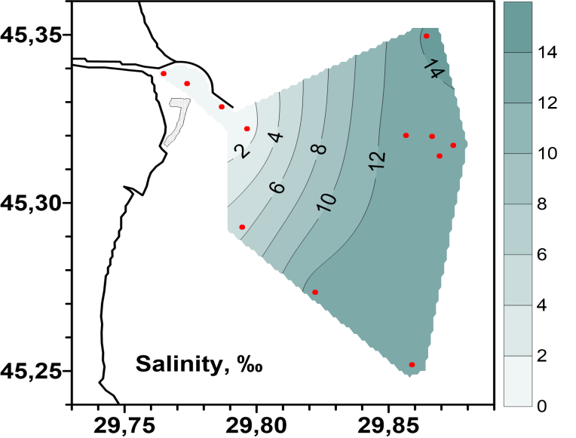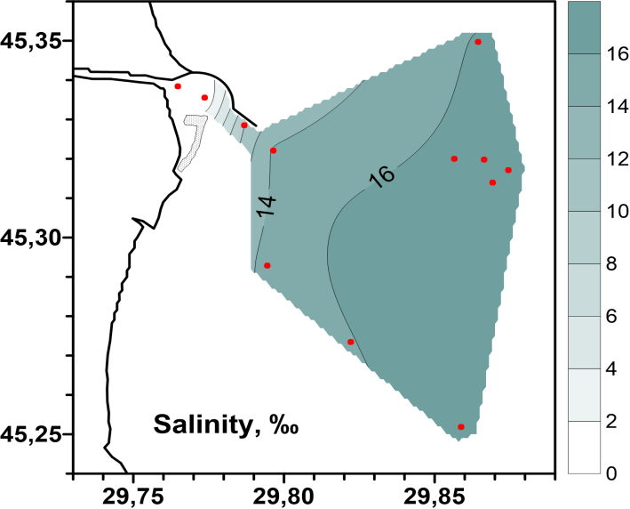
a b
Figure 1.4 - Distribution of seawater salinity (‰) on the surface (a) and bottom (b) horizons. at the Danube landfill, August 11, 2020

The parameters of the spatial distribution of water transparency fluctuated in the range of 0,5-1,0 m in the area of the navigable course and increased to 5,0-7,5 m in remote areas of the landfill (Fig. 1.5 a).
Sampling of bottom sediments was performed at all landfill stations. Only three stations showed the presence of zones of secondary siltation (Fig. 1.5 b), this is the deep part of the bars of the navigable section (St. № 7-2 and 8) and the area east of the island Bird (St. 19).

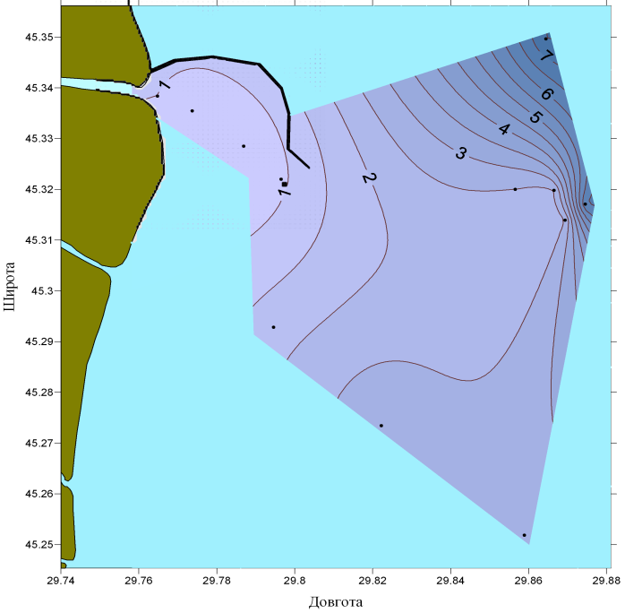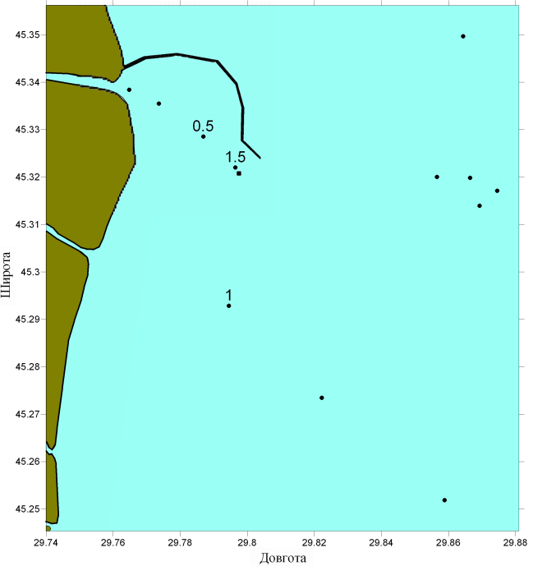
a b
Figure 1.5 - Distribution of seawater transparency (a) and silt thickness (cm) on the bottom layer of sediments (b) at the Danube landfill, August 11, 2020

Results of hydro chemical investigations in Ukrainian waters in 2020

General parameters – T⁰C, Salinity, pH, Oxygen, BOD₅, TSS

Range of variations of general parameters in UA national waters in 2020 are presented in Tables 2.1 – 2.2.

Table 2.1 - Range of variations of general parameters in the surface layer of UA national waters in 2020
 | T  ⁰C | Salinity  ⁰/₀₀ | pH | O₂  mg/L | O₂  % | TSS  mg/L
Danube delta (August 2020)
Min | 24.0 | 0.20 | 8.24 | 10.7 | 125 | 4.00
Max | 26.0 | 14.4 | 8.59 | 12.2 | 155 | 20.7
Average | 25,2 | 8.44 | 8.49 | 11.5 | 141 | 11.1
Island Zmeinyi 2020
Min | 11.6 | 9.27 | 8.20
Max | 25.8 | 17.9 | 8.74
Average | 21.0 | 16.13 | 8.38

Table 2.2 - Range of variations of main chemical quality parameters in the bottom layer of UA national waters in 2020

 | T  ⁰C | Salinity  ⁰/₀₀ | pH | O₂  mg/L | O₂  % | TSS  mg/L
Danube delta (Augusty 2020) ¹
Min | 23.0 | 0.20 | 8.30 | 5.47 | 69.9 | 4.73
Max | 26.0 | 16.4 | 8.53 | 12.0 | 138 | 28.8
Average | 24.4 | 12.8 | 8.44 | 9.35 | 114 | 12.7
Island Zmeinyi ² 2020
Min | 11.6 | 15.8 | 8.21
Max | 25.2 | 17.9 | 8.54
Average | 20.6 | 16.6 | 8.37
¹ On the depth 5,0 - 22,0 m
² On the depth 8,0 m

The values of pH in the Danube Delta in surface layer of water were minimal - 8,24 (рН units) at station 19 and maximal - 8,59 (рН units) at station 10-4 (Tab. 2.1, Fig. 2.1 a). In the bottom layer the minimum pH value (8,30 pH units) was recorded at a depth of 20 m in the area of station 18, and the maximum pH (8.53 pH units) at station 6 in the northern part of the landfill (Tab. 2.2, Fig. 2.1 b).
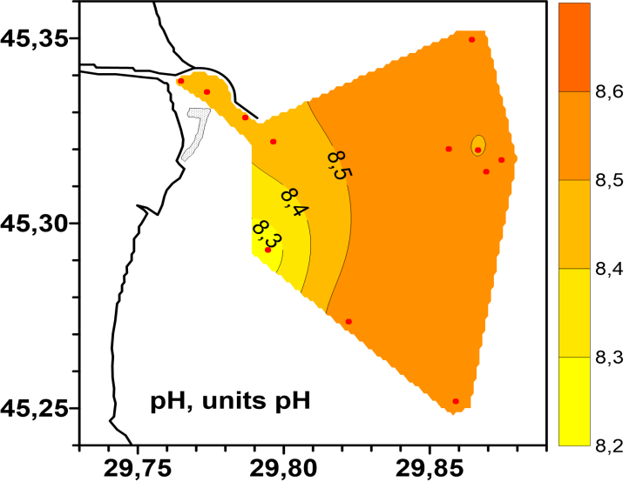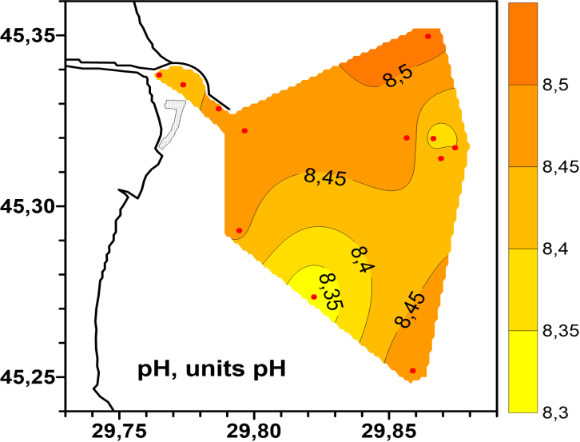
а b
Figure 2.1 - Spatial distribution of pH (units of pH) in the surface a) and bottom b) layers of the water on the seaside of the aim Bystriy in August 2020
The concentrations of dissolved oxygen in the surface layer of water varied from 10,7 to 12,2 mg/l (Tab.2.1). The maximum of oxygen in the Danube delta area in August was registered at station 10-2, minimum – at station 8 (Fig. 2.2 a).
The concentrations of dissolved oxygen in the bottom layer of water varied from 5,47 to 12,0 mg/l (Tab.2.2). The maximum of oxygen in the Danube delta area in August was registered at station 10-2, minimum – at station 18 (Fig. 2.2 b).

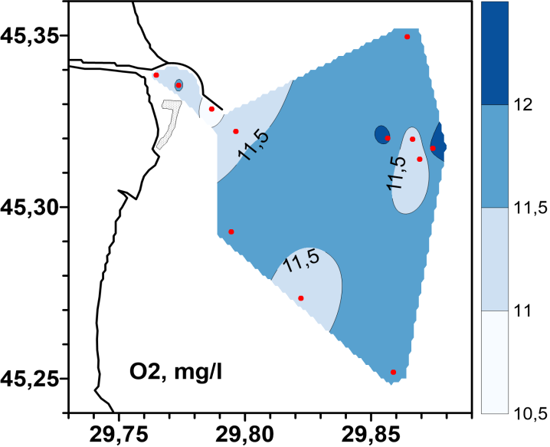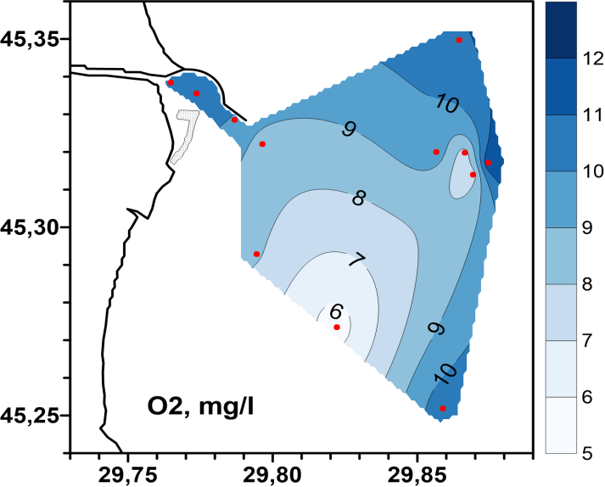
а b
Figure 2.2 - Spatial distribution of dissolved oxygen (absolute content)
in the surface a) and bottom b) layers of water on the seaside of the aim Bystriy in August 2020

The range of variation of dissolved oxygen in the surface layer of water ranged from 125 to 155 % saturation (Tab.2.1, Fig. 2.3 a), which indicates an improvement in the oxygen regime in the study area. Hypoxia phenomena that are characteristic of the bottom waters of the study area in August 2020 were not detected. The minimum value of water oxygen saturation in the bottom layer (69.9 %) was recorded at station 18 in the south-eastern part of the landfill (Tab.2.2, Fig. 2.3 b).
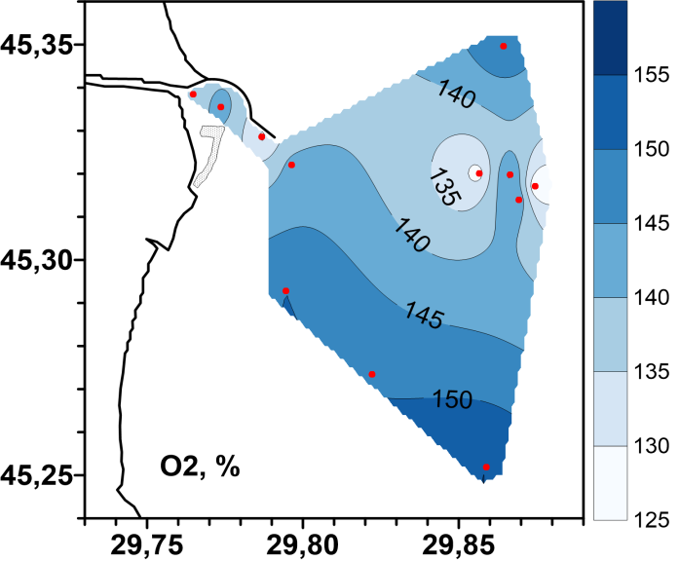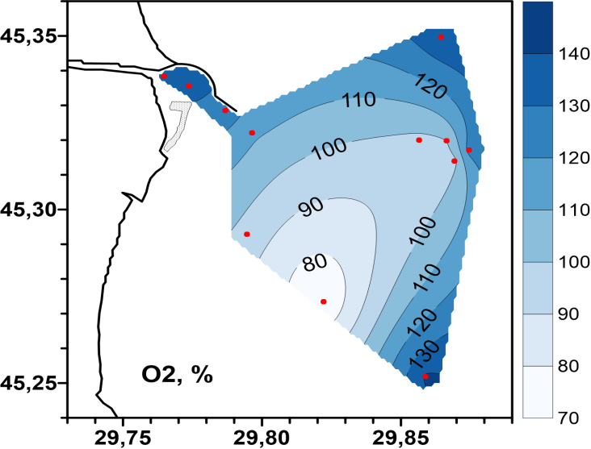
а b
Figure 2.3 - Spatial distribution of dissolved oxygen (% saturation)
in the surface a) and bottom b) layers of the water on the seaside of the aim Bystriy in August 2019

Concentrations of suspended solids were maximum at stations 7 - 7-2 of the shipping channel. The maximum of TSS (28.8 mg/l) was recorded in the bottom layer of station 7 (Table 2.2., Fig. 2.4 b).

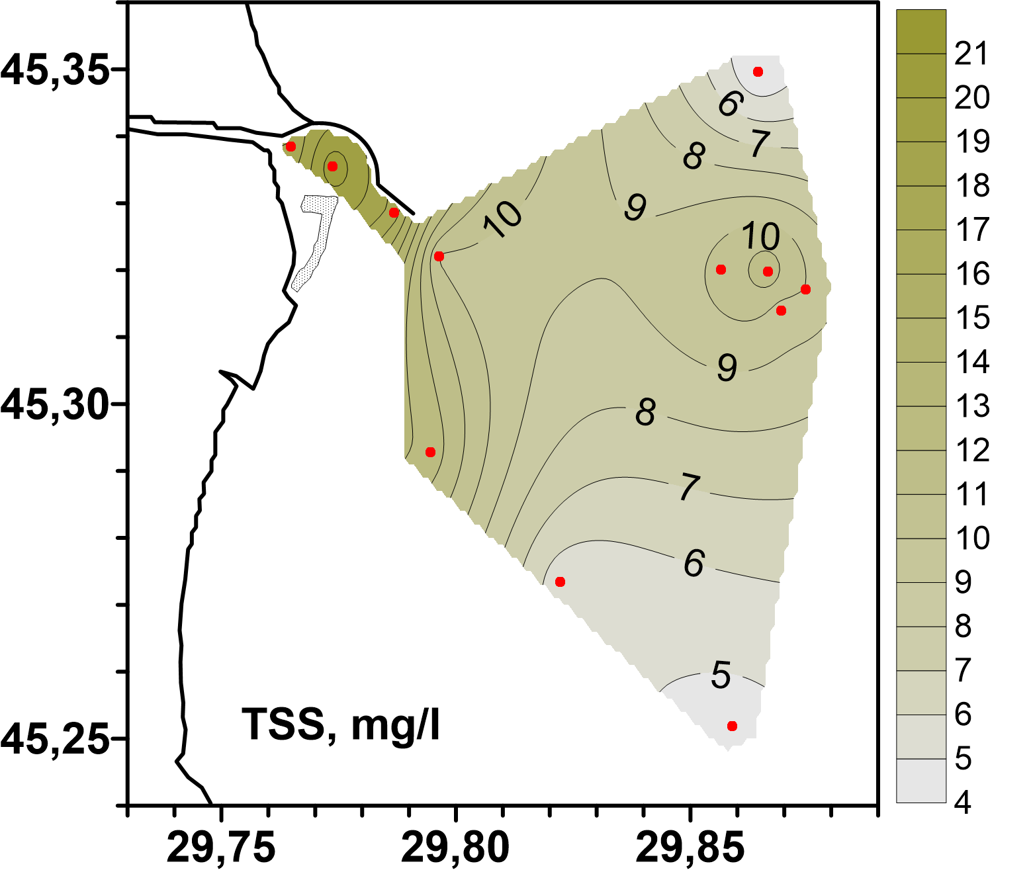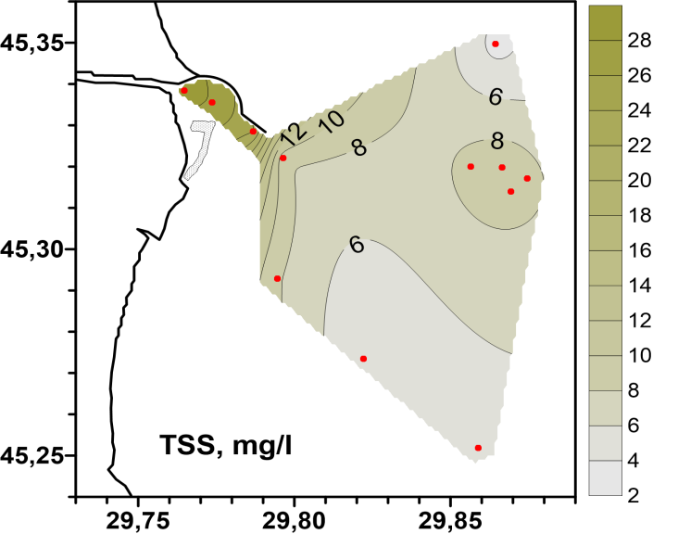
а b
Figure 2.4 - Spatial distribution of total suspended solids in the surface a) and the bottom b) layers of the water on the seaside of the aim Bystriy in August 2020
3 Pollution of marine environment

3.1 ECOLOGICAL CONDITION OF SEAWATER BY CONTENT OF POLLUTANTS

The status of seawater and bottom sediments was assessed for such pollutants as: trace metals (TM), organochlorine pesticides (OCPs), polychlorinated biphenyls (PCBs) and polyaromatic hydrocarbons (PAHs).
The pollution factor (Kz) was used to assess the level of pollution.
Kz reflects the concentration of all pollutants of the same type in a certain period of time in a given area. This factor is invented as the sum of the ratios of the concentration of each pollutant to its maximum permissible concentration, in accordance with EU Directive 2013/39/EU (MAC-EQS), or the maximum permissible concentration according to Ukrainian legislation (MPC), to the number of measurements performed in a given period of time. The accuracy of displaying the state of the regon using this factor depends on the number of monitoring stations in the study area and the number of observations over the past period of time. The overal assessment of the ecological condition of water or bottom sediments in the study area is determined by the worst assessment of the group of pollutants.

Calculation formulas:

Kz
$$CR=\frac{C_{mon}}{C_{Treshold}}$$
$$Kz=\frac{1}{n}\sum_{i=0}^{n}{CR_{i}}$$

Where: CR is contamination ratio

The ecological condition of sea water with the help of Kz is estimated:

- Very good when Kz is less than 0,5;
- Good when Kz from 0,5 to 1,0;
- Satisfactory when Kz from 1,0 to 2,5;
- Bad when Kz from 2,5 to 5,0;
- Very bad when Kz is more than 5,0.

The north-western part of the Black Sea (NWP of BS) is assessed by the open sea distribution areas and by water bodies of certain “Transitional Waters” and “Coastal Waters areas” in accordance with the Water Framework Directive 2000/60/EC (WFD) (Figure 3.1).

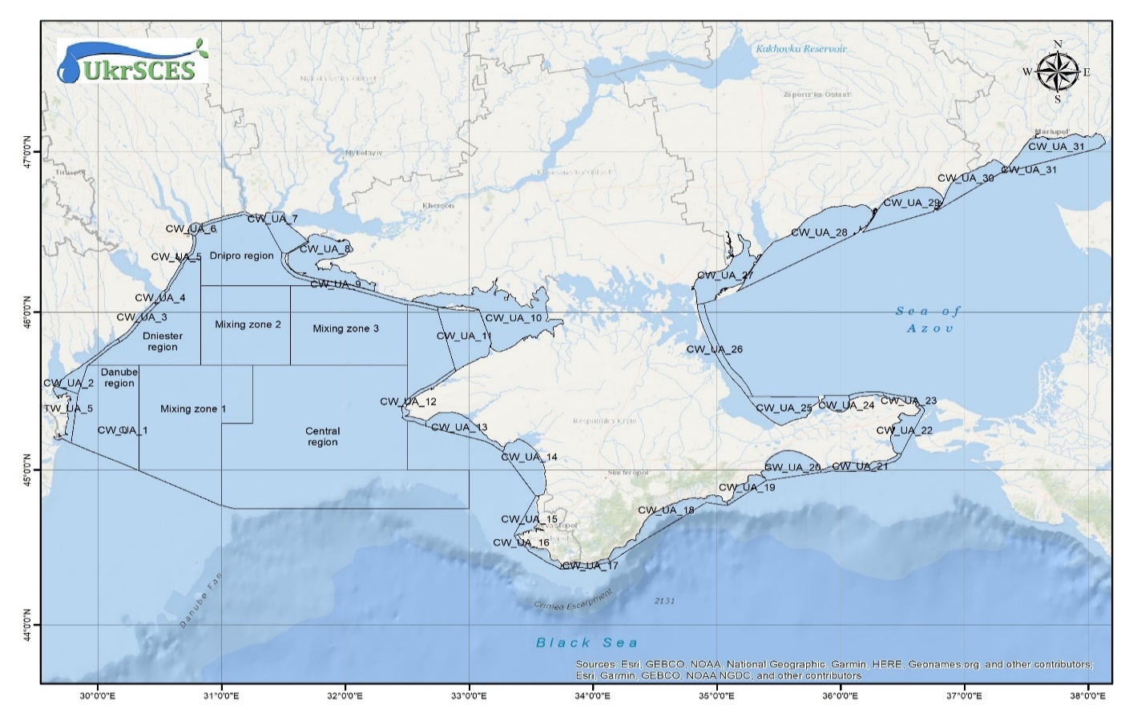Figure 3.1 - Map of areas of the marine environment of the NWP of BS

3.1.1 Ecological assessment of the state of sea water for the content of toxic metals

Table 3.1 and Figure 3.2 show the values of Kz of TM and Kz for mercury (Hg), cadmium (Cd), lead (Pb), nickel (Ni) in the surface and bottom layers of water according to 2020 data by study areas. The environmental assessment was carried out in accordance with EU Directive 2013/39/EU (MAC-EQS).

Table 3.1 - Kz TM sea water by research areas in 2020
Study areas | Sampling horizon | Kz ТМ | Kz Cd | Kz Hg | Kz Pb | Kz Ni
CW1 | surface | 0,22 | 0 | 0,89 | 0 | 0
CW4 | surface | 0,07 | 0,26 | 0 | 0 | 0
CW5 | surface | 0,19 | 0,30 | 0,36 | 0,09 | 0
CW6 | surface | 0,09 | 0,16 | 0 | 0,21 | 0
CW7 | surface | 0,16 | 0,58 | 0 | 0,04 | 0
TW5 | surface | 0,36 | 0,04 | 1,39 | 0 | 0
TW5 | bottom | 0,34 | 0,13 | 1,24 | 0 | 0
Danube region | surface | 0,34 | 0,06 | 1,28 | 0 | 0
Danube region | bottom | 0,33 | 0,09 | 1,22 | 0 | 0

In 2020, Kz TM in all areas correspond to a very good environmental condition, but in the area of TW5 and the Danube area in the surface and bottom layers of water recorded increased concentrations of mercury, Kz Hg corresponds to a satisfactory environmental condition.

a)

b)

c)
a) - Kz TM in surface and bottom layer of water
b) - Kz individual TM in surface layer of water
c) - Kz individual TM in bottom layer of water
Figure 3.2 - Kz TM in sea water by regions in 2020

Figure 3.3 shows the contributions of individual metals to the pollution of the TM group.

The biggest contribution to the pollution of the TM group was made by:
- Area CW1 - mercury in the surface layer of water;
- Area CW4 - cadmium in the surface layer of water;
- Area CW5 - cadmium and mercury in the surface layer of water;
- Area CW6 - cadmium and lead in the surface layer of water;
- Area CW7 - cadmium in the surface layer of water;
- Area TW5 - mercury in the surface and bottom layers of water;
- Danube region - mercury in the surface and bottom layers of water.

a)

b
a - in surface layer of water
b – in bottom layer of water
Figure 3.3 - The contribution of individual metals to the pollution of sea water by region in 2020

3.1.2 Ecological assessment of the state of sea water by region according to the content of organic pollutants of agricultural origin (OPAO)

Table 3.2 and Figure 3.4 show the Kz for individual OPAO and the average Kz for OPAO in the surface and bottom layers of water according to 2020 by region. The environmental assessment was carried out in accordance with EU Directive 2013/39/EU (MAC-EQS).

Table 3.2 - Kz OPAO of the surface and bottom layers of sea water in 2020

Study areas | Sampling horizon | Кz ОPAO | Кz DDT¹ |  | Кz ∑ДДТ² | Кz ∑HCH³ | Кz HCB⁴ | Кz heptachlor | Кz ∑ cyclodiene pesticides⁵ | Kz Atrazine | Кз Chlorpyrifos
CW1 | surface | 6,31 | 7,58 |  | 3,42 | 0,95 | 0 | 38 | 0,5 | 0 | 0
CW4 | surface | 28,8 | 0,78 |  | 0,34 | 0,12 | 0 | 226 | 2,92 | 0,04 | 0
CW5 | surface | 11,8 | 1,65 |  | 0,87 | 0,55 | 0,02 | 90,3 | 1,23 | 0,02 | 0
CW6 | surface | 8,53 | 0,46 |  | 0,2 | 0,06 | 0 | 65,9 | 1,63 | 0,01 | 0
CW7 | surface | 40,0 | 0 |  | 0 | 0,1 | 0 | 319 | 0,77 | 0 | 0
TW5 | surface | 69,5 | 1,78 |  | 0,89 | 0,32 | 0 | 552 | 1,01 | 0 | 0
TW5 | bottom | 48,1 | 7,58 |  | 3,75 | 1,56 | 0 | 370 | 1,99 | 0 | 0
Danube region | surface | 128 | 0,87 |  | 0,62 | 0,74 | 0 | 1023 | 1,45 | 0 | 0
Danube region | bottom | 156 | 2,84 |  | 1,44 | 1,12 | 0 | 1240 | 1,37 | 0,01 | 0
1 – p,p-dichlorodiphenyltrichloroethane  2 - the sum of DDT and its metabolites  3 - the sum of lindane and its isomers  4 - hexachlorobenzene |  |  |  | 5 – the sum of aldrin, dildrin and endrin

In 2020, Kz OPAO in all regions corresponds to a very bad environmental condition. The main pollutant among the group OPAO is heptachlor, Kz heptachlor in the surface and bottom layers of water in all areas corresponds to a very bad environmental condition.
Also, in many areas, elevated concentrations of the following pollutants were recorded:
- DDT and its metabolites, Kz DDT in the surface water layer in the areas CW1, CW5, TW5, Danube region and in the bottom water layer in the Danube region, corresponds to a very bad, bad and satisfactory ecological condition.
- lindane and its isomers, Kz ∑HCH in the surface and bottom layers of water in the Danube region, corresponds to a satisfactory ecological condition.
- aldrin, dildrin and endrin, Kz ∑cyclodiene in the surface layer of water in the areas CW4, CW5, CW6, TW5, the Danube region and in the bottom water layer in TW5 and the Danube region corresponds to a bad and satisfactory ecological condition.
Kz other OPAO have a very good ecological condition.

a)

b)

c)
a - Kz OPAO in the surface and bottom layers of water
b - Kz individual OPAO in the surface layer of water
c - Kz individual OPAO in the bottom layer of water
Figure 3.4 - KZ OPAO in sea water by region in 2020
Figure 3.5 shows the contributions of individual OPAO to the pollution of the OPAO group.

a)

b)
a - surface layer of water
b - bottom layer of water
Figure 3.5 - The contribution of individual OPAO to the pollution of sea water by region in 2020

The greatest contribution to pollution by the OPAO group is made by the concentration of heptachlor in all areas in the surface and bottom layers of water.
In the CW1 region, the main effect of heptachlor concentrations is supplemented by the effect (about 23 %) of DDT and its metabolites (fig. 3.5 a).

3.1.3 Ecological assessment of the state of sea water by regions on the content of organic pollutants of industrial origin (OPIO)

Table 3.3 and Figure 3.6 show Kz of the OPIO group and Kz of the individual OPIO of the surface and bottom layers of sea water by regions in 2020.
As there are no restrictions on non-dioxin PCBs concentrations in EU Directive 2013/39, the maximum available concentrations for polychlorinated biphenyls (PCBs) are taken from the EAC recommendations, OSPAR SIME 2008, were also considered separately individual PCB groups from PCB-16 to PCB-65 (Ar-1254) and from PCB-28 to PCB-73 (Ar-1260), relative to EN.
Kz of polyaromatic hydrocarbons (PAHs) was calculated relative to MAC-EQS EU 2013/39.

Table 3.3 - Kz OPIO of surface and bottom layers of sea water in 2020
Study areas | Sampling horizon | Кz ОPIO | Кz ПCB 101 | Кz ПCB 118 | Кz ПCB 153 | Кz ПCB 138 | Кz ПCB 180 | Кz naphthalene | Кz anthracene | Кz fluoranthene | Кz benzo(b)fluoranthene | Кz benzo(k)fluoranthene | Кz benzo(a)pyrene | Кz benzo(g,h,i)perylene
CW1 | surface | 22,9 | 84,0 | 102 | 0,76 | 88,5 | 0 | 0 | 0 | 0,01 | 0,03 | 0 | 0,03 | 0
CW4 | surface | 29,4 | 33,5 | 47,7 | 0 | 266 | 0 | 0 | 4,21 | 0,73 | 0 | 0,26 | 0,09 | 0
CW5 | surface | 15,3 | 34,7 | 68,5 | 0,69 | 78,8 | 0,98 | 0 | 0,38 | 0,10 | 0 | 0 | 0,01 | 0
CW6 | surface | 10,8 | 4,50 | 23,0 | 0,16 | 101 | 0 | 0 | 1,05 | 0,38 | 0 | 0 | 0 | 0
CW7 | surface | 5,81 | 0 | 6,35 | 0 | 62,5 | 0 | 0 | 0,81 | 0,08 | 0 | 0 | 0 | 0
TW5 | surface | 13,7 | 42,3 | 66,5 | 0,62 | 55,5 | 0 | 0 | 0 | 0,01 | 0 | 0 | 0 | 0
Danube region | surface | 59,2 | 208 | 302 | 3,20 | 196 | 1,28 | 0 | 0,02 | 0,03 | 0,07 | 0,02 | 0,01 | 0
TW5 | bottom | 25,6 | 86,8 | 128 | 1,51 | 90,8 | 0 | 0 | 0,01 | 0,01 | 0 | 0 | 0 | 0
Danube region | bottom | 25,1 | 101 | 126 | 1,10 | 72,3 | 0,05 | 0 | 0,03 | 0,03 | 0,02 | 0 | 0,02 | 0

a)

b)

c)
a - Kz OPIO in the surface and bottom layers of water
b - PCBs in the surface layer of water
c - Kz PCBs in the bottom layer of water
Figure 3.6 - Kz OPIO of sea water by regions in 2020

In 2020, Kz OPIO in all areas in the bottom and surface layers of water correspond to a very bad ecological condition. Concentrations of individual PCBs 101, 118, 138 had the greatest impact on the ecological condition and their Kz corresponds to a very bad ecological condition.
High concentrations were also recorded in the following areas:
- PCB 153, Kz of PCB-153 in the surface water layer in the Danube region and in the bottom water layer in the TW5 region and the Danube region corresponds to a bad and satisfactory ecological condition;
- PCB-180, Kz PCB-180 in the surface layer of water in the Danube region of satisfactory ecological condition;
- Anthracene, Kz anthracene in the surface layer of water in the area of CW4 and CW6 corresponds to a bad and satisfactory ecological condition.
Table 3.4 and Figure 3.7 show the average values of the total of PAHs (∑ PAHs), benzo(a)pyrene equivalent (B(a)Peq) and the total of carcinogenic PAHs (∑ carc PAHs) in the surface and bottom layers of seawater by region in 2020 year. Indicators ∑ PAHs in areas CW4, CW5, CW6, CW7 are at a high level. B(a)Peq and the total of carcinogenic PAHs in the CW4 area is significantly higher than in other areas.
Table 3.4 – Total PAHs, benzo(a)pyrene equivalent and sum of carcinogenic PAHs of the surface and bottom layers of sea water in 2020
Study areas | Ʃ PАHs | B(a)Peq | Σ carc PАHs | Ʃ PAHs | B(a)Peq | Σ carc PAHs
Study areas | surface layer of water |  |  | bottom layer of water
CW1 | 14,2 | 0,86 | 1,25
CW4 | 1138 | 13,31 | 11,07
CW5 | 235 | 4,52 | 2,44
CW6 | 880 | 4,13 | 0,65
CW7 | 192 | 1,43 | 0
TW5 | 7,97 | 0,58 | 0,38 | 12,3 | 0,09 | 0
Danube region | 38,4 | 1,36 | 3,11 | 57,4 | 1,62 | 1,95

a)

b)
a - the surface layer of water
b – the bottom layer of water
Figure 3.7 - Mean values of ∑ PAHs, B(a)Peq and ∑ carc PAHs in surface
and bottom layers of sea water by region in 2020

Figure 3.8 shows the contributions of individual OPIO to the pollution of the OPIO group.

The largest contribution to the pollution of the OPIO group was made by regions:
- Area CW1, CW4, CW5, TW5 region, Danube region - PCB 101,118,138;
- Area CW6, CW7 - PCB 118,138.

a)

b)
a - the surface layer of water
b – the bottom layer of water
Figure 3.8 - The contribution of Kz individual OPIO in sea water pollution
by regions in 2020

3.2 ECOLOGICAL STATE OF BOTTOM SEDIMENTS
BY THE CONTENT OF POLLUTANTS

The condition of bottom sediments was assessed for such pollutants as: toxic metals (TM), organochlorine pesticides (OCPs) and polyaromatic hydrocarbons (PAHs). 2020 was considered in the evaluation process.
The ecological condition of bottom sediments is estimated by means of Kz:

for ТМ: |  | for organic compounds:
Very good when Kz is less than 0,5; |  | Very good when Kz is less than 0,2;
Good when Kz from 0,5 to 1,0; |  | Good when Kz from 0,2 до 1,0;
Satisfactory when Kz  from 1,0 to 1,25; |  | Satisfactory when Kz  from 1,0 to 5,0;
Bad when Kz from 1,25 to 2,5; |  | Bad when Kz from 5,0 to 25;
Very bad when Kz is more than 2,5 |  | Very bad when Kz is more than 25

3.2.1 Toxic metals in bottom sediments

Table 3.5 and Figure 3.9 show Kz TM and Kz individual TM in bottom sediments by region in 2020. For toxic metals Kz was calculated in relation to EN. In general, Kz TM in all areas correspond to a very good and good ecological condition.

Table 3.5 - Kz TM in bottom sediments by region in 2020.
Study areas | Кz ТМ | Кz Cd | Кz Cr | Кz Cu | Кz As | Кz Hg | Кz Pb | Кz Zn | Кz Ni | Кz Co
CW1 | 0,10 | 0,07 | 0,03 | 0,11 | 0,14 | 0,11 | 0,06 | 0,18 | 0,09 | 0,12
TW5 | 0,48 | 0,22 | 0,68 | 0,83 | 0,35 | 0,36 | 0,23 | 0,60 | 0,49 | 0,55
Danube region | 0,54 | 0,3 | 0,67 | 0,76 | 0,33 | 0,55 | 0,27 | 0,64 | 0,91 | 0,47

Figure 3.9 - Kz TM in bottom sediments by region in 2020

Figure 3.10 shows the contributions of individual TM to the pollution of bottom sediments by the TM group. In the studied areas, the metals are distributed almost equally, more present Co, Ni, Zn, Hg, Cu, Cr.

Figure 3.10 - The contribution of Kz of individual TMs to the pollution
of bottom sediments by region in 2020

3.2.2 Ecological assessment of the state of bottom sediments by regions according to the content of organic pollutants of agricultural origin (OPAO)

Table 3.6 and Figure 3.10 show the OPAO in the bottom sediments by region in 2020. For OPAO Kz was calculated in relation to the limit concentrations of EN.

Table 3.6 - KZ OPAO in bottom sediments by regions in 2020

Study areas | Кz ОPAO | Кz ∑DDT | Кz α-HCH | Кz β-HCH | Кз Lindane | Кz ∑HCH | Кz HCB | Кz heptachlor | Кz aldrine | Кz dildrine
TW5 | 2,52 | 19,4 | 0,36 | 0 | 0 | 0,18 | 0,26 | 0,10 | 0 | 2,44
Danube region | 6,23 | 36,9 | 0,54 | 0,05 | 14,4 | 0,43 | 0,30 | 0,21 | 0,19 | 2,98

Figure 3.10 - KZ OPAO in bottom sediments by regions in 2020

According to the calculated KZ OPAO according to bottom sediments the following indicators of an ecological condition are noted on regions:
- in the water body TW5 Kz OPAO corresponds to a satisfactory ecological condition, Kz ∑DDT corresponds to a bad ecological condition and Kz dildrin corresponds to a satisfactory ecological condition.
- in the Danube region Kz OCPs corresponds to a bad ecological condition, high level of pollution of ∑DDT, lindane and dildrin is recorded (Kz ∑DDT and Kz lindane corresponds to a very bad and bad ecological condition, Kz dildrin corresponds to a satisfactory ecological condition).
Figure 3.11 shows the contributions of individual OPAO to the pollution of bottom sediments by the OPAO group.
In the TW5 region, the main pollutants are DDT and its metabolites, in the Danube region, the main contributors to pollution are DDT and its metabolites and lindane.

Figure 3.11 - The contribution of individual OPAO to the pollution of bottom sediments
by region in 2020.

3.2.3 Ecological assessment of the state of bottom sediments by regions on the content of organic pollutants of industrial origin (OPIO)

Table 3.7 and Figure 3.12 show the Kz OPIO in the bottom sediments by region in 2020. Kz of individual OPIO was calculated in relation to concentration limits on EN.

Table 3.7 - Kz groups of OPIO and individual OPIO in bottom sediments by regions in 2020.
Study areas | Кz OPIO | Кz Ar-1254 | Кz Ar-1260 | Кz naphthalene | Кz phenanthrene | Кz antracene | Кz fluoranthene | Кz benzo(a)anthracene | Кz chrizene | Кz benzo(k)fluoranthene | Кz benzo(a)pyrene | Кz indeno(1,2,3cd)pyrene | Кz benzo(g,h,i)perylene
TW5 | 0,05 | 0,53 | 0,04 | 0 | 0 | 0 | 0 | 0 | 0 | 0 | 0 | 0 | 0
Danube region | 0,15 | 1,16 | 0,06 | 0,16 | 0,03 | 0,02 | 0,10 | 0,08 | 0,01 | 0,06 | 0,06 | 0,04 | 0,04

Figure 3.12 - Kz OPIO in bottom sediments by region in 2020

In general, it is noted that in all studied areas Kz OPIO corresponds to a very good ecological condition, but increased concentrations of group PCB Ar-1254 were recorded in the Danube region (Kz Ar-1254 corresponds to a satisfactory ecological condition).
The contributions of individual OPIO to the pollution of bottom sediments by the OPIO group shown in Figure 3.13 indicate that in the TW5 region the main polluting compounds are PCBs of groups Ar-1254 and Ar-1260, in the Danube region the main contributors to pollution are PCBs of group Ar-1254, naphthalene and fluoranthene.

Figure 3.13 - The contribution of individual OPIO to the pollutionof bottom sediments
by region in 2020

Table 3.8 shows the average values of ∑PAHs, B(a)Peq, sums of carcinogenic PAHs and geochemical markers, which are calculated from the average values of PAHs concentrations for bottom sediments by region in 2020.
Geochemical markers, such as the ratio of phenanthrene to anthracene (Ph/An), the ratio of pyrene and fluoranthene to the sum of chrizene and phenanthrene (Py+Flu)/(Chr+Ph)), the ratio of anthracene to the sum of compounds with a molecular weight of 178 (An/178), the ratio of fluoranthene to pyrene (Flu/Py), the ratio of fluoranthene to the sum of fluoranthene and pyrene (Flu/(Flu+Py)), the ratio of benzo(a)anthracene to the sum of compounds with a molecular weight of 228 (BaA/228).

Table 3.8 - Average PAHs concentrations and geochemical markers of bottom sediments in 2020
Study areas | ∑PАHs | B(a)Peq | ∑carc PАHs | Ph/  An | (Py+Flu)/  (Chr+Ph) | An/178 | Flu/  Py | Flu/  Flu+Py | BaA/228
TW5 | 0,07 | 0,002 | 0 |  |  |  | 0 | 0
Danube region | 15,2 | 2,905 | 10,6 | 1,90 | 1,70 | 0,30 | 1,00 | 0,50 | 0,90

The ammount of carcinogenic PAHs exceeds B(a)Peq in the Danube region, which characterizes the presence of compounds, that do not have a high toxic effect on biological objects, but can accumulate in them.
Table 3.9 provides an assessment of the nature of PAHs contamination and the probable sources of contamination by geochemical markers in the regions in 2020.
According to the average data of PAHы concentrations in the bottom sediments of the water region TW5, pollution coming without the participation of combustion processes predominates. In the Danube region, the bottom sediments are dominated by pollution from the combustion of raw materials and fuel.
In terms of bottom sediment pollution, the water region TW5 and the Danube region are characterized as slightly polluted.

Table 3.9 - Assessment of the nature of PAHs contamination and probable sources of pollution in 2020
Study areas | Assessment Ph/An (Probability 66,7%) | Assess-ment (Py+Flu)/  (Chr+Ph) (Probability 70,8%) | Assessment An/178 (Probability 50%) | Assessment Flu/Py (Probability 50%) | Assess-ment Flu/Flu+Py  (Probability 79,2%) | Assessment BaA/228 (Probability 66,7%) | Classification of samples by contamination
TW5 |  |  |  | petrogenic PAHs | petrogenic PAHs (most TPHs and products of their combustion) |  | slightly contaminated
Danube region | pyrogenic PAHs | pyrogenic PAHs | PAHs from diesel oil, shale oil, coal and  some samples of crude oil | спалюван-ня вугілля | pyrogenic PAHs (burning of kerosene and grass, most coals and wood; creosote) | pyrogenic PAHs | slightly contaminated

3.3 ECOLOGICAL STATE OF BIOLOGICAL OBJECTS BY CONTENT

OF POLLUTION

The state of biological objects was assessed according to the content of the following pollutants: toxic metals (TMs), organochlorine pesticides (OCPs), and polyaromatic hydrocarbons (PAHs).
The assessment method was used the pollution factor (Kz.
Limiting permissible concentrations of pollutants were taken from the DIRECTIVE 2013/39/EU OF THE EUROPEAN PARLIAMENT AND OF THE COUNCIL of 12 August 2013 and from the Commission Regulation (EC) No 1881/2006 of 19 December 2006 setting maximum levels for certain contaminants in foodstuffs (Text with EEA relevance).
General assessment of biological objects, ecological state in the studied area was made coming out of the worst grades of groups of pollutants.

The ecological condition of biological objects is estimated by means of Kz:

for ТМ: |  | for organic compounds:
Very good when Kz is less than 0,5; |  | Very good when Kz is less than 0,2;
Good when Kz is from 0,5 to 1,0; |  | Good when Kz is from 0,2 to 1,0;
Satisfactory when Kz is  from 1,0 to 1,25; |  | Satisfactory when Kz is  from 1,0 to 5,0;
Bad when Kz is from 1,25 to 2,5; |  | Bad when Kz is from 5,0 to 25;
Very bad when Kz is more than 2,5 |  | Very bad when Kz is more than 25

3.3.1 Pollution of biological objects, assessment of the state of pollution

Table 3.10 shows the Kz groups and individual TM, OPAO, OPIO in biological objects caught in different water bodies and regions of the Black Sea according to 2020.
KZ of pollutants were calculated relative to MAC-EQS. The results of the calculated values of Kz provide the following estimates of the levels of contamination of the captured biological objects:
- in a water body CW1 are in a bad condition, Kz OPAO – very badly (Kz of heptachlor corresponds to very bad level, Kz of hexachlorobenzene corresponds to a satisfactory level). In general, the indicators of mollusk contamination remained at the level of the baseline assessment.
- in the Dniester region are in bad condition, Kz OPAO - bad (Kz hexachlorobenzene corresponds to a very bad level), Kz OPIO - satisfactory (Kz fluoranthene corresponds to a bad level, Kz benzo(a)pyrene corresponds to a satisfactory level).
- in the Danube area are in a bad condition, Kz OPAO - very bad (Kz hexachlorobenzene corresponds to a bad level, Kz heptachlor corresponds to a very bad level), Kz OPIO - bad (Kz fluoranthene corresponds to a bad level, Kz benzo(a)pyrene corresponds to a satisfactory level.
- in Mixing Zone 2 are in poor condition, Kz OPAO - bad (Kz hexachlorobenzene corresponds to a bad level), Kz OPIO - satisfactory (Kz fluoranthene corresponds to a bad level, Kz benzo(a)pyrene corresponds to a satisfactory level).

Table 3.10 - Kz TM, OPAO, OPIO in biological objects for 2020
The name of the biological object | Study areas | Кz TM  (Hg) | Кz OPAO | Кz OPIO | Кz HCB | Кz heptachlor | Кz fluoranthene | Кz benzo(a)pyrene
mussel | CW1 | 0,75 | 239 | 0,53 | 1,82 | 476 | 0,41 | 0,65
mussel | Dniester region | 0,65 | 15,2 | 3,18 | 30,3 | 0 | 5,07 | 1,28
mussel | Danube region | 0,50 | 922 | 6,54 | 22,6 | 1821 | 11,3 | 1,81
mussel | Mixing Zone 2 | 0,55 | 9,45 | 4,97 | 18,9 | 0 | 7,50 | 2,44
Rapana | CW1 | 1,75 | 1874 | 5,02 | 16,4 | 3731 | 9,13 | 0,90
Rapana | Dniester region | 1,20 | 9033 | 7,00 | 5,45 | 18060 | 5,50 | 8,50
Rapana | Danube region | 1,63 | 17,2 | 73,3 | 34,3 | 0 | 139 | 7,80
Rapana | Mixing Zone 2 | 2,23 | 87,3 | 2,46 | 26,2 | 148 | 4,53 | 0,39

Figures 3.14 - 3.15 show the average degree of contamination of TM, OPAO, OPIO biological objects caught in different regions and water bodies NWSBS.

Figure3.14 - Average Kz TM mussels and rapans by areas of NWSBS

According to the indicators of Kz values, the level of mollusk contamination by regions is as follows:
- in the water body CW1 are in a very bad condition, Kz TM (mercury) - bad, Kz OPAO - very bad (Kz heptachlor corresponds to a very bad level, Kz hexachlorobenzene corresponds to a bad level), Kz OPIO - bad (Kz fluoranutene corresponds to a bad level.
- in the Dniester region are in a very bad condition, Kz TM (mercury) - satisfactory, Kz OPAO - very bad (Kz hexachlorobenzene corresponds to a bad level, Kz heptachlor corresponds to a very bad level), Kz OPIO - satisfactory (Kz fluorantene corresponds to a bad level Kz benzo(a)pyrene corresponds to a bad level).
- in the Danube region are in bad condition, Kz TM (mercury) - bad, Kz OPAO - bad (Kz hexachlorobenzene corresponds to a very bad level), Kz OPIO - bad (Kz fluoranthene corresponds to a very bad level, Kz benzo (a) pyrene corresponds to a bad level).
- in the Mixing Zone 2 are in very bad condition, Kz TM (mercury) - bad, Kz OPAO - very bad (Kz hexachlorobenzene corresponds to a very bad level, Kz heptachlor corresponds to a very bad level), Kz OPIO - satisfactory (Kz fluoranthene corresponds to satisfactory level).

Figure 3.15 - Kz OPAO and OPIO mussels and rapana by regions of NWSBS

4 ASSESSMENTS of biodiversity and coastal communities of the North-West Black Sea region

Introduction
Biodiversity is one of the most important environmental characteristics of marine ecosystems. The biological organisms are objective indicators of the environmental state. There is a particularly large variety of hydrobionts in the coastal waters of aquatic ecosystems, their community structure reflects their environmental status. Biocenoses play an important role in key ecosystem processes (primary production, food webs, recycling, etc.). But they are exposed to anthropogenic impact, which poses a risk to their functionality. Marine Framework (MSFD, Directive 2008/56/ EC) requires EU Member States to achieve good environmental status (GES). To achieve GES, it is necessary to constantly monitor the status of marine ecosystems.
Hydrobiological studies of the north-western part of the Black Sea (NWBS) were conducted to assess the quality of marine ecosystems by biological methods and to assess the state of pelagic and benthic aquatic communities in different parts Ukraine marine territories.
Phytoplankton
In 2020, 170 microalgae taxa belonging to 17 classes were registered at the stations of the Odessa region: Bacillariophyceae 82, Dinophyceae 43, Chlorophyceae 10, Chlorodendrophyceae 1, Trebouxiophyceae 4, Cyanophyceae 10, Prymnesolageliochecece, Ebriophyceae 1, Euglenoidea 3, Imbricatea 1, Flagellata 1, Prasinophyceae 1, Prymnesiophyceae 3, Xanthophyceae 1. As in previous years, the basis of species diversity was formed by diatoms and dinoflagellates, as shown in Figure 4.1.

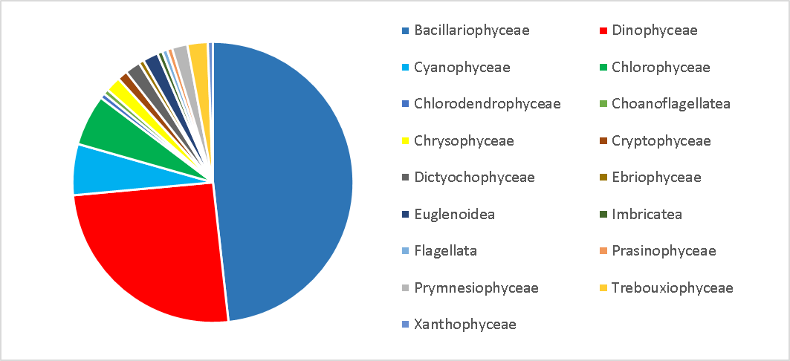
Figure 4.1 - Taxonomic diversity of microalgae at stations in the Odessa region in 2020

The Shannon diversity index ranged from 0,27 to 2,4 bit*ind., with an average value of 1,37 bit*ind. The changes of average monthly values of Shannon index are shown in Figure 4.2
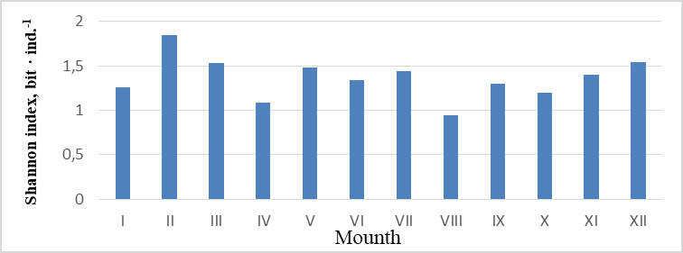
Figure 4.2 - Average monthly values of Shannon index in Odessa region in 2020

The abundance of microalgae varied from 6 to 1018 thousand cells*L⁻¹, biomass from 0,56 to 2825 mg*m⁻³, with an average number of 117 thousand cells*L⁻¹ and biomass 297 mg*m⁻³, which is slightly lower than in previous years, as shown in Figure 4.3.

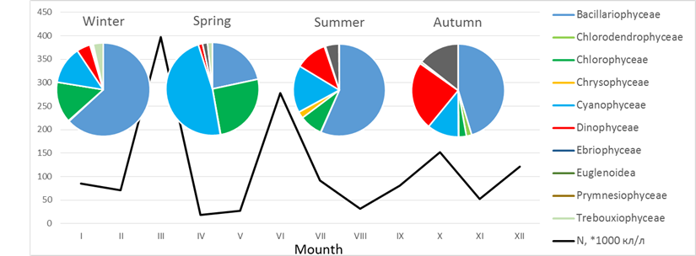
а
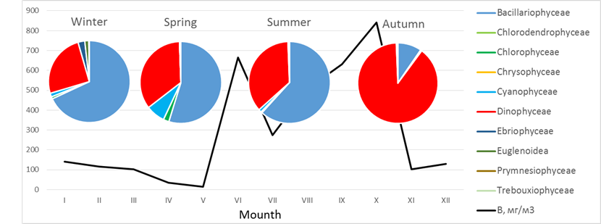
b
а) abundance; b) biomass.
Figure 4.3 - Quantitative indicators of phytoplankton in the Odessa region in 2020

In 2020, 3 maxima of quantitative indicators were observed: in spring (due to the development of freshwater small species Jaaginema kisselevii, Merismopedia punctata and Monoraphidium contortum), in summer (due to the development of diatoms Coscinodiscus janischii and Skeletonema costatum) and large (due to development of great dinoflagellate Lingulodinium polyedrum), but the level of "bloom" was exceeded only in autumn.
In the coastal waters of the Odessa region, the quality of water at all stations may be assessed as "very good", except for Koblevo station, where due to the "bloom" of microalgae, water quality was assessed as "very bad". Assessment of water quality according to the Menchinick index is presented in Figure 4.4. In the summer, the MEC % index was also used to assess water quality, according to which water quality at all stations may be assessed as "very good". Thus, the water quality in the waters in all studied water bodies of the Odessa region is GES, except for Koblevo station in the CW7 water body, where the water quality was assessed as "very bad".

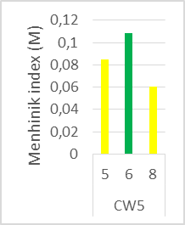 | 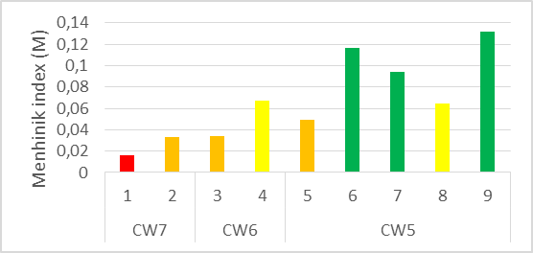
а | б
а) June 2020; b) October 2020
Figure 4.4 - Assessment of water quality according by the Menchinick index in the water areas of the Odessa region (1 - Koblevo, 2 - the port "South", 3 - Luzanivka, 4 - the port "Odessa", 5 - the beach "Dolphin", 6 - the beach named after Chkalov, 7 - Cape Small Fountain, 8 – the beach "Arcadia", 9 - Dacha Kovalevsky)

Thus, in 2020 it is possible to note the stable tendency to improve the ecological state of sea waters and further deutrophication, which is reflected in the decrease in the quantitative indicators of microalgae. However, the registered cases of phytoplankton mass development indicate that the state of the marine environment of coastal waters remains unstable.
The results of the ecological status assessment by the concentration of chlorophyll-α (μg*L⁻¹) in water bodies of Odesa region in 2020 are presented in Table 4.1.

Table 4.1 - Ecological status assessment by the concentration of chlorophyll-α (μg*L⁻¹) in water bodies of Odesa region in 2020
Date | Station | Concentration of chlorophyll-α (μg*L⁻¹)
15.06.2020 | the beach "Dolphin" | 1,07
15.06.2020 | the beach named after Chkalov | 1,17
15.06.2020 | Cape Small Fountain | 0,79
15.06.2020 | the beach "Arcadia" | 0,90
02.10.2020 | the port "South" | 9,57
02.10.2020 | Koblevo | 58,40
02.10.2020 | Luzanivka | 5,94
02.10.2020 | the port "Odessa" | 5,38
02.10.2020 | the beach "Dolphin" | 4,23
02.10.2020 | the beach named after Chkalov | 2,36
02.10.2020 | Cape Small Fountain | 3,00
02.10.2020 | the beach "Arcadia" | 3,87

Autumn monitoring of coastal water bodies revealed that the value of chlorophyll-α for 4 stations corresponded to the category "Medium". The stations of “Arcadia” beach, and port “Odessa” and Cape Small Fountain corresponded to the category "Moderate", and Koblevo and the port "South" to the category "Bad".
Thus, in the spring of 2020, the ecological state at coastal monitoring stations was better than at the end of summer and the beginning of autumn, when due to a sharp increase in chlorophyll-α concentrations, the ecological status at a number of stations was “Bad”.
Zooplankton
During 2020, 63 taxa of marine, brackish and freshwater complexes were identified in all studied water areas. The basis of biodiversity was copepods, but mostly due to bentho-pelagic species of the orders Harpacticoida and Canueloida (Canuella perplexa, Clytemnestra sp., Dactylopusia sp., Ectinosoma sp., Harpacticus sp., Heterolaophonte sp., Metis ignea, Thalestris longimana. Harpacticoida gen. sp.). A single finding of the genus Clytemnestra sp. is of a great importance, because the representatives of this genus have not previously been observed in the Black Sea.
The change in mesozooplankton abundance in 2020 in the Odessa region is shown in Figure 4.5.
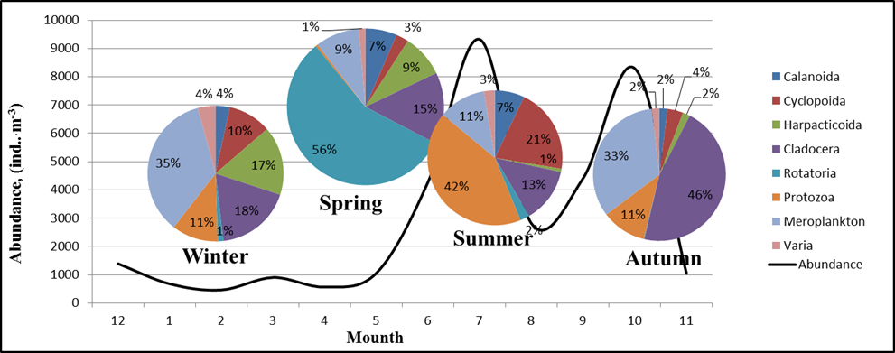
Figure 4.5 - Average abundance of mesozooplankton (ind.*m⁻³) in Odessa region at 2020

In general, the abundance and biomass were slightly higher than in previous years. The change in mesozooplankton biomass during 2020 in the Odessa region is shown in Figure 4.6.
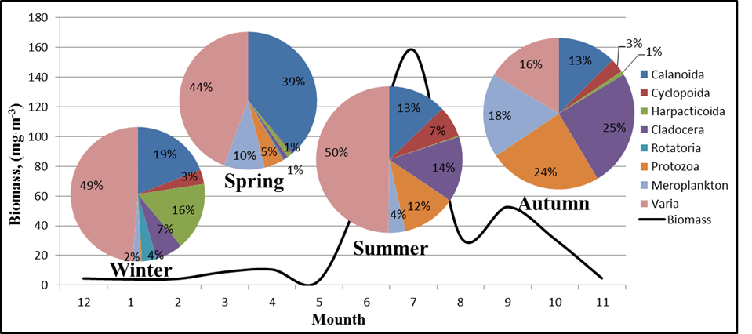
Figure 4.6 - Average biomass of mesozooplankton (mg*m⁻³) in Odessa region at 2020

The Shannon diversity index varied from 0.54 bit*ind⁻¹ in November to 3.10 bit*ind⁻¹in May and averaged 2.09 ± 0.70 bit*ind⁻¹, which is shown on Figure 4.7.

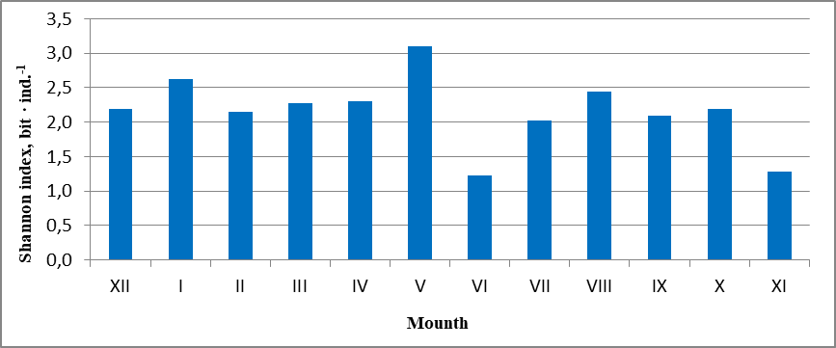
Figure 4.7 - Shannon index (by number) of zooplankton in the Odessa region in 2020

In general, for the year, the state of the water area by mesozooplankton indicators may be assessed as "Good" (Table 4.2).

Table 4.2 - Quantitative indicators of mesozooplankton of the Odessa region in 2020 and assessment of the ecological status
Indicator | Winter | Spring | Summer | Autumn | whole year
abundance (ind*m⁻³) | 748 ± 466 | 613 ± 498 | 14882 ± 30580 | 4908 ± 3718 | 7262 ± 18782
biomass (mg*m⁻³) | 13,773 ± 6,602 | 10,848 ± 8,74 | 432,466 ± 756,682 | 97,407 ± 79,56 | 192,758 ± 476,735
N.scintillans,  % | 4,231 ± 5,983 | 0,301 ± 0,522 | 18,562 ± 12,166 | 18,717 ± 23,472 | 10,453 ± 22,093
Copepoda, % | 58,71 ± 32,59 | 65,676 ± 28,597 | 23,484 ± 20,821 | 22,393 ± 12,61 | 42,566 ± 30,662
Shannon index (bit*ind⁻¹) | 2,326 ± 0,466 | 2,559 ± 1,375 | 1,897 ± 0,587 | 1,855 ± 0,707 | 2,159 ± 0,718

In 2020, there was no large development of the non-forage zooplankton, Noctiluca and jellyfish, in addition, biomass and diversity were slightly better than last year, indicating a gradual improvement in the ecological status of the water area.

Macrozoobenthos
The most important role in the qualitative composition of macrozoobenthos is played by crustaceans (Crustacea), mollusks (Mollusca) and worms (Vermes). In quantitative macrozoobenthos samples in the coast of the Odessa region (experimental depths from 0.5 to 10 m) 34 taxa were registered, which is shown in Figure 4.8.

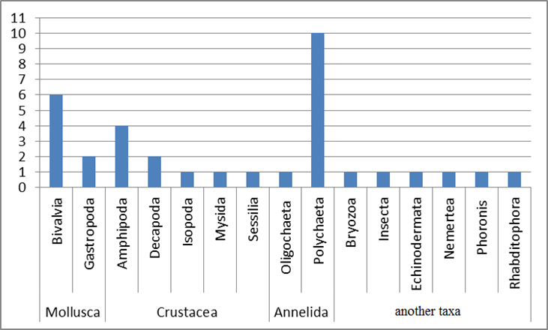
Figure 4.8 - Taxonomic composition of macrozoobenthos in coastal water bodies in 2020

The maximum frequency was observed for: Mytilus galloprovincialis Lamarck, 1819, Chaetogammarus olivii (H. Milne Edwards, 1830), Microdeutopus gryllotalpa Costa, 1853, Alitta succinea (Leuckart, 1847), Capitella capitata europaea Wu, 1964, Nephtys hombergii Savigny in Lamarck, 1818, Spio filicornis (Müller, 1776), Stylostomum ellipse (Dalyell, 1853), Tubificoides sp., Nemerthae gen. sp.
The spatial distribution of the macrozoobenthos of the coastal waters is heterogeneous and depends mainly on the characteristics of the soil, depth, external hydrological changes, location (distance) from hydrotechnical structures and the growing anthropogenic impact in the summer. The state of environmental health by macrozoobenthos indicators was assessed using the indices established by MSFD: AZTI Marine Biotic Index and m-AMBI.
Six macrozoobenthos communities were found in the studied coastal water massifs. The characteristics of water bodies are given in accordance with descriptors 1.4 and 6.
Mytilus galloprovincialis - Alitta succinea community
D 1: The community included 27 taxa of species rank and above, of which the most diverse were Polychaeta - 8, Crustacea - 8, other groups were represented less diversely, so Mollusca accounted for 5 species, other taxa 1-2 species. Abundance ranged from 0,5 to 4,5 ind.*m⁻² (2.3 ± 0.5 ind.*m⁻²), and biomass from 5 to 1800 g*m⁻² (218 ± 185 g*m⁻²), Shannon index 1,6-2,3.
D 4: The dominant biomass in the community were filtrators Mytilus galloprovincialis Lamarck, 1819, which accounted for from 80 to 95% of biomass, and their share in abundance did not exceed 25 %. Polychaetes Alitta succinea, Capitella capitata, Nephtys hombergii, Spio filicornis belong to the mixotrophic group of collectors-seistonophages, which contributed to the abundance of up to 50 %.
D 6: The ratio of species groups according to the attitude to organic matter was the following: I - 8.2 %, II - 7.2 %, III - 63.4 %, IV - 1.2 %, V – 20,1, which corresponds to a moderately disturbed state that also coincide with the AMBI index assessment (3.46), the value of the M-AMBI index ranged from 0,59 to 0,95. Thus, the ecological status of this macrozobenthos community may be assessed as "good".
Lentidium mediterraneum community
D1: The species diversity of the community was low, only six species were registered: Lentidium mediterraneum (O. G. Costa, 1830), Mytilus galloprovincialis, Aonides paucibranchiata Southern, 1914, Alitta succinea (Leuckart, 1847), Tubificoides sp., Spio filicornis. Abundance was 2700 thousand ind.*m⁻², biomass 21 g*m⁻², Shannon index 1,2. All indicators were 2-5 times lower than last year.
D4: The dominant species accounted for 95 % of biomass. At the same time, a significant share of the abundance, up to 45 %, belonged to polychaetes Aonides paucibranchiata Southern, 1914 and young mussels Mytilus galloprovincialis in total.
D6: The community is formed on a sand-shell substrate. The ratio of species groups according to the attitude to organic matter was the following: I – 0 %, II – 53,1 %, III – 44,4 %, IV – 0 %, V – 2,5 %, AMBI index – 2,278, M-AMBI index - 0,6. Thus, the ecological status of the macrozobenthos community may be assessed as "not GES".
Chamelea gallina (Linnaeus, 1758) community
D1: The community included 10 speceis: Alitta succinea, Aonides paucibranchiata, Capitella capitata, Chamelea gallina, Lentidium mediterraneum, Mytilus galloprovincialis, Nephtys hombergii, Rissoa splendida Eichwald, 1830, Scolelepis squamata (O.F. Müller, 1776) , Spio filicornis. The abundance was from 25 ind.*m⁻², the biomass up to 40 g*m⁻², Shannon index 2,32.
D4: The filtrators Chamelea gallina (Linnaeus, 1758) were dominant by biomass that accounted for up to 85% of biomass. Young mussels Mytilus galloprovincialis contributed up to 50% in abundance.
D6: The community is formed on a sand-shell substrate. The ratio of species groups according to the attitude to organic matter was the following: I - 8,1 %, II - 4,1 %, III - 85,1 %, IV – 0 %, V - 2,7, AMBI index – 2,8, M-AMBI index - 0,71. Thus, the ecological status of the macrozobenthos community may be assessed as "GES".
Cerastoderma glaucum (Bruguière, 1789) - Alitta succinea community.
D1: The species diversity of the community was low, only six species were registered: Abra nitida (O.F. Müller, 1776), Capitella capitata, Alitta succinea, Cerastoderma glaucum, Spio filicornis, Tubificoides sp. The abundance was up to 0,7 thousand ind.*m⁻², and biomass from 4 g*m⁻², Shannon index 2,37.
D4: The filtrators Cerastoderma glaucum and Abra nitida were dominant by biomass that accounted from 70 % to 90 % of biomass, but their share in abundance varied from 18 % to 20 %. Polychaeta Capitella capitata, Alitta succinea, Spio filicornis in total formed from 75 % of abundance.
D6: Groups were formed on the following substrates: silted sand, shell sand, shell rock. The ratio of species groups according to the attitude to organic matter was the following: I – 0 %, II – 0 %, III - 59,1 %, IV – 0 %, V - 40,9 %, AMBI index – 4,2, M-AMBI index - 0,52. Thus, the ecological status of the macrozobenthos community may be assessed as "not GES".
Abra nitida community
D1: In the community, there were registered 7 species: (Abra nitida, Alitta succinea, Capitella capitata, Paramysis kroyeri (Czerniavsky, 1882), Polydora limicola Annenkova, 1934, Spio filicornis, Tubificoides sp.). The abundance was up to 0,7 thousand ind.*m⁻², and biomass from 2,7 g*m⁻², Shannon index 2,53.
D4: The dominant by biomass and abundance was Abra nitida, which accounted 35 %.
D6: The community was formed on the substrate sand-shell-rock. The ratio of species groups according to the attitude to organic matter was the following: I - 0 %, II – 9 %, III - 63,9 %, IV – 0 %, V – 27,3 %, AMBI index – 3,68, M-AMBI index - 0,60. Thus, the ecological status of the macrozobenthos community may be assessed as "GES".
Spio filicornis community
D1: In the community, there were registered 10 species: (Abra nitida, Alitta succinea, Capitella capitata, Chaetogammarus olivii, Dexamine spinosa (Montagu, 1813), Idotea balthica (Pallas, 1772), Nemertea, Polydora limicola, Spio filicornis, Tubificoides sp.). The abundance was from 3,9 thousand ind.*m⁻² , and biomass from 27,08 g*m⁻², Shannon index 2,36.
D4: The dominant species was Spio filicornis that accounted up to 50 % in total biomass and abundance. The main trophic groups of invertebrates in this community were detritophagous collectors.
D6: The community was formed on the substrate sand-shell-rock. The ratio of species groups according to the attitude to organic matter was the following: I – 0 %, II - 3,5 %, III - 76,5 %, IV – 0 %, V – 20 %, AMBI index – 3,55, M-AMBI index - 0.67. Thus, the ecological status of the macrozobenthos community may be assessed as "GES".
Based on our research, only 33 % of the studied benthic area of coastal water bodies was characterized by good ecological status, and 67 % were characterized as "not good" ecological status.
Macrophytobenthos
In 2020, 26 species of macrophytes (2 species of the genus Zostera) were registered in storm emissions at the Odessa coast, including 13 species (2 species – sea grass), which were found only in emissions. Compared to the entire Black Sea, the coastal part of the NWBS has a poor flora. As a result of macrophytobenthos studies of the coastal parts of the Dnieper region, Odessa Bay and Dniester region, 40 species were identified: 38 benthic algae and 2 species of sea grass, which belong to 4 phyla: Chlorophyta, Rhodophyta, Ochrophyta and Tracheophyta. Among the general diversity of macrophyte algae, red algae dominate - 19 species (47,5 %), the second place is occupied by green algae - 17 species (about 42.5%). Only 2 species of brown algae were found (about 5 %). The contribution of higher aquatic plants was 5 %. Identified macrophytes belong to 6 classes, 13 orders, 17 families, 25 genera. The highest number of species belong to the genera Cladophora and Ulva (5 species each), Ceramium (4 species), Chaetomorpha, Acrochaetium, Carradoriella and Zostera (2 species each). Only 1 species represents each of the genera Bryopsis, Ulothrix, Urospora, Blidingia, Ulvella, Bangia, Pyropia, Stylonema, Hydrolithon, Grania, Callithamnion, Antithamnion, Chondria, Polysiphonia, Peyssonnelia, Erythrocladia, Myriactula, Punctaria.
The leading families during the study period were Cladophoraceae - 7 species (17.5 %), Ulvaceae and Ceramiaceae - 5 species each (12.5 %), Rhodomelaceae - 4 species (10 %), Acrochaetiaceae - 3 species (7.5 %). Other families are represented by 2 (Ulotrichaceae, Bangiaceae, Chordariaceae, Zosteraceae) or 1 species (Bryopsidaceae, Kornmanniaceae, Ulvellaceae, Goniotrichaceae, Hydrolithaceae, Callithamniaceae, Peyssonneryaceae). This indicates a simplified composition of the studied algae flora that consists mainly of single-species and two-species families, and only four families contain 3, 4, 5 and 7 species of algae, respectively.
Three new for Odessa Bay species of macrophytes were found. In autumn, red alga Chondria capillaris was found at two open areas of Luzanivka beach (CW6_3) in storm emissions. Its S/Wp is 28,6 ± 1,8 m²*kg⁻¹. Its ecological and floristic characteristics is the following: boreal-tropical species, annual, oligosaprobe, leading. In the middle of the last century, the species was widespread in the Odessa Bay and characteristic for the Egorlytsko-Tendrivsko-Dzharilgatsko-Perekopsky hydrobotanical region of the Black Sea.
In the summer, green plate algae Blidingia minima was identified for the first time in the water body of CW5 (the beach of sanatorium named after Chkalov). It was the second dominant together with Ulva intestinalis and gave a significant biomass (0,294 kg*m⁻²), which exceeded the biomass of Ulva (0,226 kg*m⁻²). B. minima is a boreal-tropical species, annual, distributed near the coast of Crimea.
To assess the state of different regions of the Black Sea, the most indicative is such a morphofunctional indicator of macrophytobenthos as the specific surface of the three dominants (S/W)_{3Dp}. It reflects the intensity of the production process associated with the state of the marine environment, especially eutrophication. Table 4.3 shows the changes in this indicator by stations and seasons.

Table 4.3 - Class of ecological status of monitoring stations according to the specific surface index of the three dominants (S/W)_{3Dp}
Region, water body, station | The specific surface of the three dominants (S/W)_{3Dp}, m²*kg⁻¹
Region, water body, station | spring |  | fall
Dnipro region  CW7  port «South» |  |  | 1 Cladophora albida  2 Ulva flexuosa  3 Ulva intestinalis | 85,5
 |  |  |  | 50,4
 |  |  |  | 36,1
Odessa Bay  CW5  beach «Dolphin» | 1 Cladophora albida  2 Cladophora vagabunda  3 Ulva intestinalis | 85,5 | 1 Cladophora vagabunda  2 Ulva flexuosa  3 Ulva intestinalis | 47,8
Odessa Bay  CW5  beach «Dolphin» |  | 47,8 | 1 Cladophora vagabunda  2 Ulva flexuosa  3 Ulva intestinalis | 50,4
Odessa Bay  CW5  beach «Dolphin» |  | 36,1 | 1 Cladophora vagabunda  2 Ulva flexuosa  3 Ulva intestinalis | 36,1
Odessa Bay  CW5  beach named after Chkalov | 1 Cladophora vagabunda  2 Ulva intestinalis  3 Carradoriella denudata | 47,8 | 1 Ulva intestinalis  2 Ceramium diaphanum  3 Ceramium virgatum | 36,1
Odessa Bay  CW5  beach named after Chkalov |  | 36,1 |  | 34,3
Odessa Bay  CW5  beach named after Chkalov |  | 56,9 |  | 25,7
Odessa Bay  CW5  Cape Small Fontaine | 1 Cladophora albida  2 Ulva flexuosa  3 Ulva intestinalis | 85,5 | 1 Ulva flexuosa  2 Ulva intestinalis  3 Ceramium arborescens | 50,4
Odessa Bay  CW5  Cape Small Fontaine | 1 Cladophora albida  2 Ulva flexuosa  3 Ulva intestinalis | 50,4 | 1 Ulva flexuosa  2 Ulva intestinalis  3 Ceramium arborescens | 36,1
Odessa Bay  CW5  Cape Small Fontaine | 1 Cladophora albida  2 Ulva flexuosa  3 Ulva intestinalis | 36,1 | 1 Ulva flexuosa  2 Ulva intestinalis  3 Ceramium arborescens | 27,4
Odessa Bay  CW5  beach «Arcadia» | 1 Cladophora vagabunda  2 Ulva flexuosa  3 Ulva intestinalis | 47,8 | 1 Ulva intestinalis  2 Ceramium arborescens  3 Ceramium virgatum | 36,1
Odessa Bay  CW5  beach «Arcadia» | 1 Cladophora vagabunda  2 Ulva flexuosa  3 Ulva intestinalis | 50,4 |  | 27,4
Odessa Bay  CW5  beach «Arcadia» | 1 Cladophora vagabunda  2 Ulva flexuosa  3 Ulva intestinalis | 36,1 |  | 25,7
Odessa Bay  CW5  Dacha Kovalevskogo | 1 Cladophora albida  2 Ulva flexuosa  3 Ulva intestinalis | 85., | 1 Cladophora albida  2 Ulva intestinalis  3 Ceramium virgatum | 85,5
Odessa Bay  CW5  Dacha Kovalevskogo | 1 Cladophora albida  2 Ulva flexuosa  3 Ulva intestinalis | 50,4 |  | 36,1
Odessa Bay  CW5  Dacha Kovalevskogo | 1 Cladophora albida  2 Ulva flexuosa  3 Ulva intestinalis | 36,1 |  | 25,7
Dniester region  CW4  Koblevo |  |  | 1 Cladophora albida  2 Cladophora vagabunda  3 Ulva flexuosa | 85,5
 |  |  |  | 47,8
 |  |  |  | 50,4

Table 4.4 shows the integrated result of the ecological status assessment for the monitoring water bodies by the three morphofunctional indicators of macrophytobenthos.

Table 4.4 - Integral assessment of monitoring stations by morphofunctional indicators of macrophytobenthos
Stations | ecological activity index of three dominants  (S/W)_{3Dp}, m²*kg⁻¹ |  | average specific surface area index of structural elements of algae  (S/W)_{x,} m²*kg⁻¹ |  | Phytocenosis surface index  (SI_{ph}) |  | Integral assessment by the average indicator
Stations | Spring | Fall | Spring | Fall | Spring | Fall
Dnipro region CW7  port «South» |  | 57,33±  2,03 |  | 50,80±  2,32 |  | 21,29 | 0,72
Odessa Bay CW5  beach «Dolphin» | 56,47±2,80 | 44,77±  2,13 | 50,40±2,17 | 46,62±  2,13 | 75,68 | 21,48 | 0,61
Odessa Bay CW5  beach named after Chkalov | 46,93±2,27 | 32,03±  1,4 | 50,56±1,91 | 42,60±  2,12 | 49,02 | 25,48 | 0,68
Odessa Bay CW5  Cape Small Fontaine | 57,33±2,03 | 37,97±  1,47 | 49,31±2,20 | 45,57±  2,15 | 29,58 | 15,58 | 0,73
Odessa Bay CW5  beach «Arcadia» | 44,77±2,13 | 29,73±  1,37 | 47,83±2,10 | 43,87±  2,09 | 55,56 | 23,86 | 0,66
Odessa Bay CW5  Dacha Kovalevskogo | 57,33±2,03 | 49,10±  1,93 | 48,83±2,23 | 42,58±  2,08 | 48,00 | 15,52 | 0,68
Dniester region CW4  Koblevo |  | 61,23±  2,93 |  | 59,96±  2,52 |  | 43,85 | 0,55

As a result of the integrated assessment of macrophytobenthos, it can be concluded that the monitoring water bodies are of the "Good" and "Satisfactorily" status classes.
Microphytobenthos
During 2020, in the microphytobenthos communities of solid (concrete, granite, shell rock, iron, mussel wings) and loose (sand) substrates of the coastal waters of NWBS, 158 species of algae which belonged to 8 phyla were found. Diatoms prevailed, numbering 106 species, which was 67,1 % in species composition. Cyanobacteria and dinoflagellates were common, 23 and 17 species, or 14,6 % and 10,8 %, respectively. Poly- and mesogalobic and β-mesosaprobic species of diatoms dominated among benthic microalgae. The most diverse genera were Nitzschia - 15 species, Navicula - 10, Licmophora and Amphora - 6, Halamphora - 5. There were fewer α-mesosaprobic diatoms (in particular, representatives of the genus Melosira). Diatoms Cocconeis costata, Navicula ramosissima, Achnanthes brevipes, Ceratoneis closterium, Cyclotella choctawhatcheeana, Tabularia fasciculata were found in most of the studied marine water bodies. Cyanobacteria were mostly of the genus Phormidium (4 species). Cyanobacteria Leptolyngbya fragilis, Lyngbya confervoides, Microcystis sp., golden alga Emiliania huxleyi were found almost everywhere. Among dinoflagellates, Gymnodinium kowalevskii, Prorocentrum cordatum, Prorocentrum micans were most often observed.
The highest qualitative and quantitative indicators of microphytobenthos development were characteristic for the most eutrophied water bodies located near the beach of sanatorium named after Chkalov (CW5) and Koblevo (CW7). Occasionally, potentially toxic cyanoprokaryotes Aphanizomenon flosaquae, Dolichospermum flosaquae, and dinoflagellate P. cordatum, P. micans, and S. acuminata were noted in the coastal waters of Odessa region. But in the autumn, the development of the potentially toxic dinoflagellate Lingulodinium polyedra was observed almost everywhere, that caused the "bloom" of sea water and fell into the group of microphytobenthos. It was most widespread in the Koblevo area, where its abundance on solid and loose substrates ranged from 34,13 to 119,56 million cells*m⁻², and biomass from 764,35 to 3615,86 mg*m⁻², respectively. In general, the state of microphytobenthos community has significantly improved compared to 2019.

5. Eutrophication

Range of variations of nutrients in different regions of UA national waters in 2020 are presented in Table 5.1 – 5.2 and corresponds pictures (Fig 5.1 – 5.5).

Table 5.1 - Range of variations of nutrients in the surface layer of UA national waters in 2020
 | PO₄  µM | P_{total}  µM | NH₄  µM | NO₂  µM | NO₃  µM | N_{total}  µM
Danube delta (August 2020)
Min | 0.16 | 0.46 | 0.00 | 0.12 | 3.46 | 34.6
Max | 1.70 | 1.82 | 1.03 | 1.73 | 86.5 | 116.2
Average | 0.56 | 0.93 | 0.30 | 0.71 | 34.8 | 77.2
Island Zmeinyi
Min | 0.10 | 0.16 | 0.14 | 0.07 | 0.00 | 13.1
Max | 0.74 | 1.49 | 14.3 | 0.79 | 3.21 | 42.8
Average | 0.42 | 0.91 | 2.24 | 0.44 | 0.61 | 26.7

Table 5.2 - Range of variations of nutrients in the bottom layer* of UA national waters in 2020
 | PO₄  µM | P_{total}  µM | NH₄  µM | NO₂  µM | NO₃  µM | N_{total}  µM
Danube delta (August 2020) ¹
Min | 0.11 | 0.36 | 0.00 | 0.04 | 1.04 | 20.9
Max | 2.10 | 2.83 | 1.09 | 1.50 | 70.9 | 98.9
Average | 0.58 | 0.94 | 0.33 | 0.41 | 21.1 | 58.4
Island Zmeinyi ² 2019
Min | 0.10 | 0.48 | 0.07 | 0.14 | 0.07 | 20.9
Max | 1.58 | 2.07 | 6.21 | 7.50 | 1.43 | 71.4
Average | 0.43 | 0.88 | 2.78 | 0.97 | 0.53 | 34.2
¹ On the depth 5,0 - 22,0 m
² On the depth 8,0 m

According to long-term observations in 2000-2020 in the coastal water body СW5 of the Odessa region of the Black Sea there is a tendency to decrease the mineral (DIP) and total phosphorus (TP). The average annual content of mineral phosphorus in this period varied from 23,9 μg/dm³, at the beginning of the XXI century, to 9,3 μg/dm³ in 2015 (Fig. 5.1). In the last five years, the average annual content of mineral phosphorus in coastal waters in this area has ranged from 9,8 μg/dm³ to 14,9 μg dm³, with an average of 12,6 μg/dm³. The level of average annual values of the concentration of mineral phosphorus in the recreational zone of the water body СW5 corresponds to a good ecological condition at the value of GES 16,4 μg/dm³.

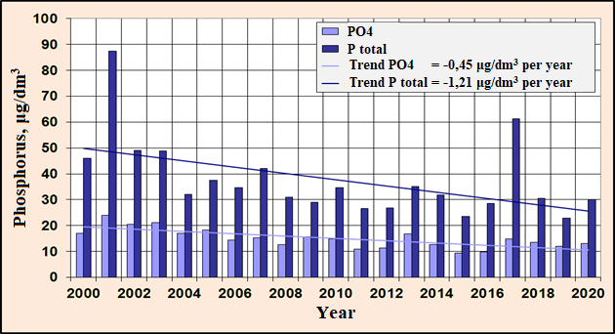
Figure 5.1 - Long-term changes in the content of mineral and total phosphorus in the coastal water body CW5 in the recreational zone of the city of Odessa

In the multi-year plan of 2000 - 2020, the content of the average annual amount of mineral forms of nitrogen (DIN) in the coastal water body СW5 of the Black Sea shows a tendency to decrease its concentration from 182,9 μg/dm³ in 2001 to 52,3 μg/dm³ in 2020. (Fig. 5.2). In the last five years, the average annual mineral nitrogen (DIN) content ranged from 52,3 μg/dm³ to 84,5 μg/dm³, with an average value of 63,4 μg/dm³. In 2020, according to the average annual DIN concentration, coastal waters in this area corresponded to GES <52.7 μg/dm³. The general tendency to decrease the DIN content in the period 2000 - 2020 was 4,57 μg/dm³ per year.

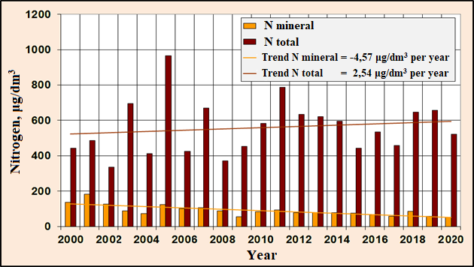
Figure 5.2 - Long-term changes in mineral and total nitrogen content
in the coastal water body СW5 in the recreational zone of the city of Odessa

The tendency to decrease the content of mineral compounds of nitrogen is determined by its individual indicators of nitrite, nitrate and ammonium nitrogen, which is shown in Figure 5.3.

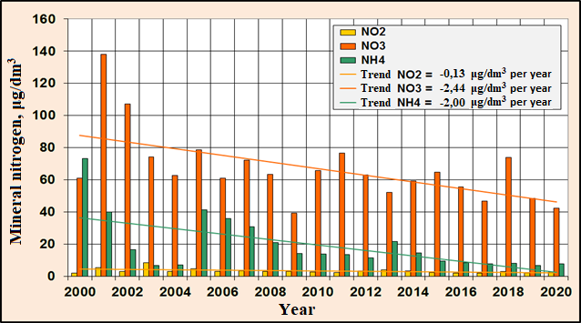
Figure 5.3 - Long-term changes in the content of mineral forms of nitrogen in the coastal water body СW5 in the recreational zone of the city of Odessa

In areas distant from industrial zones, in 2020, trophicity of coastal waters, according to the average annual value of the TRIX index (5,0 units), corresponded to the "moderate" level. (Fig. 5.4).
In the long-term variability of the trophicity indicator in the coastal waters of the recreation zone in the Odessa region there is a tendency of decreasing and some improvement in the quality of marine coastal waters, comparing with the beginning of the 2000s. The linear trend of the index of trophic index of TRIX index has the angular coefficient of – 0,046 units per year.

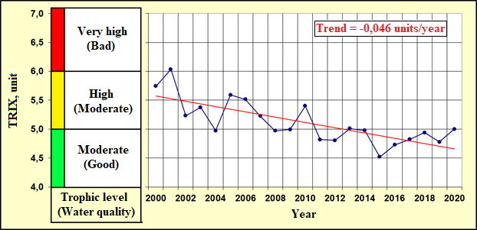
Figure 5.4 – The long-term changes of trophicity and quality of the coastal waters
of Odessa region of NWBS by TRIX index

6. Other activities of the RAC PMA

6.1 Overview of monitoring data flows to the RDB-P by Ukraine in 2020 years

Table 6.1 Statistics of the sample types by years
 |  | 2010 | 2011 | 2012 | 2013 | 2014 | 2015 | 2016 | 2017 | 2018 | 2019 | 2020
Ukraine | BathingWater | - | - | - | - | - | - | - | - | - | - | -
Ukraine | Biota | - | - | + | + | + | + | + | + | + | + | +
Ukraine | Sediment | + | + | + | + | + | + | + | + | + | + | +
Ukraine | Water | + | + | + | + | + | + | + | + | + | + | +

Table 6.2 Statistics of the number of parameter groups by years (water, sediment, biota)
Ukraine |  |  | SampleType-Water
ParameterGroup/Year | 2010 | 2011 |  | 2012 | 2013 | 2014 | 2015 | 2016 | 2017 | 2018 | 2019 |  | 2020
Detergents | 1 | 1 |  | 1 |  | 1
Hydrochemistry | 7 | 7 |  | 6 | 6 | 6 | 6 | 7 | 7 | 7 | 7 |  | 6
Hydrology | 2 | 2 |  | 2 | 2 | 2 | 2 | 2 | 2 | 2 | 2 |  | 2
Nutrients | 7 | 7 |  | 7 | 7 | 7 | 7 | 7 | 7 | 7 | 7 |  | 7
PAHs | 17 | 1 |  | 16 |  |  |  | 16 | 17 | 17 | 18 |  | 18
PCBs | 11 | 19 |  | 22 | 19 | 19 | 22 | 23 | 23 | 23 | 32 |  | 26
Pesticides | 13 | 13 |  | 11 | 13 | 13 | 12 | 12 | 12 | 12 | 14 |  | 14
Petroleum Hydrocarbons | 1 | 1 |  | 1 | 1 | 1 | 1 | 1 | 1 |  | 1
Phenols | 1 | 1
Photosynthetic pigments |  |  |  | 1
Radionuclides | 1
Trace (heavy) metals | 10 | 11 |  | 11 | 11 | 11 | 10 | 11 | 10 | 10 | 10 |  | 10

Ukraine | SampleType- sediment
ParameterGroup/Year | 2010 | 2011 | 2012 | 2013 | 2014 | 2015 | 2016 | 2017 | 2018 | 2019 | 2020
Detergents
Hydrochemistry |  | 2 | 2 | 2 | 2 | 2 | 2 | 2 | 2
Nutrients
PAHs | 17 | 17 | 17 |  |  |  | 16 | 17 | 17 | 18 | 18
PCBs | 9 | 12 | 22 | 20 | 19 | 21 | 23 | 23 | 31 | 32 | 26
Pesticides | 13 | 11 | 11 | 13 | 11 | 12 | 12 | 12 | 12 | 14 | 14
Petroleum Hydrocarbons | 1 | 1 | 1 | 1 | 1 | 1 | 1 | 1 | 1 | 1 | 1
Phenols | 1 | 1 | 1 | 1 | 1 | 1 | 1 | 1 | 1 | 1 | 1
Radionuclides
Trace (heavy) metals | 11 | 11 | 12 | 11 | 12 | 10 | 12 | 12 | 11 | 12 | 11

Ukraine | SampleType-Biota
ParameterGroup/Year | 2012 | 2013 | 2014 | 2015 | 2016 | 2017 | 2018 | 2019 | 2020
PCBs | 20 | 19 | 20 | 23 | 23 | 23 | 30 | 31 | 26
Pesticides | 11 | 11 | 11 | 12 | 12 | 12 | 12 | 14 | 14
Trace (heavy) metals | 11 | 10 | 11 | 10 | 11 | 11 | 11 | 11 | 11
PAHs |  |  |  |  | 16 | 16 | 16 | 17 | 18
Table 6.3 – Statistics of the number of samples by parameter groups and by years (water)

Ukraine | SampleType-Water
ParameterGroup/  Year | 2010 | 2011 | 2012 | 2013 | 2014 | 2015 | 2016 | 2017 | 2018 | 2019 | 2020
Detergents | 72 | 219 | 10 |  | 10
Hydrochemistry | 1190 | 1596 | 1245 | 333 | 210 | 204 | 560 | 807 | 189 | 530 | 204
Hydrology | 292 | 371 | 665 | 134 | 212 | 312 | 302 | 409 | 48 | 275 | 124
Nutrients | 1369 | 2203 | 778 | 399 | 646 | 678 | 999 | 1337 | 288 | 957 | 396
PAHs | 34 | 7 | 208 |  |  |  | 889 | 1564 | 867 | 1422 | 432
PCBs | 42 | 365 | 831 | 384 | 342 | 657 | 1357 | 2139 | 1179 | 2560 | 624
Pesticides | 52 | 235 | 401 | 235 | 214 | 346 | 708 | 1116 | 612 | 1120 | 336
Petroleum Hydrocarbons | 159 | 299 | 39 | 27 | 18 | 4 | 61 | 64 |  | 30
Phenols | 149 | 168 | 15
Radionuclides | 7
Trace (heavy) metals | 112 | 492 | 433 | 194 | 180 | 480 | 525 | 990 | 509 | 780 | 240

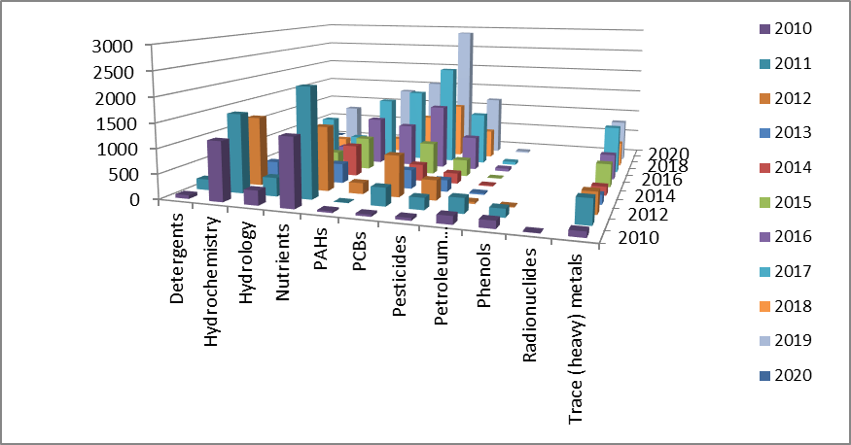
Figure 6.1 - Distribution of the number of samples by parameter groups and years (water)
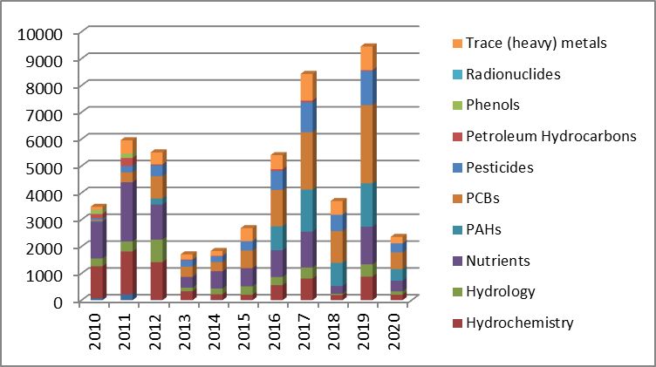
Figure 6.2 - Total numberof samples for each parameters group (water)
Table 6.4 – Statistics of the number of samples by parameter groups and by years (sediment)

Ukraine | SampleType- sediment
ParameterGroup/  Year | 2010 | 2011 | 2012 | 2013 | 2014 | 2015 | 2016 | 2017 | 2018 | 2019 | 2020
Hydrochemistry |  | 84 | 41 | 34 | 20 | 56 | 64 | 88 | 24
PAHs | 204 | 289 | 374 |  |  |  | 416 | 833 | 442 | 702 | 216
PCBs | 32 | 489 | 707 | 723 | 266 | 684 | 621 | 1081 | 614 | 1344 | 312
Pesticides | 52 | 495 | 350 | 415 | 154 | 359 | 324 | 564 | 312 | 582 | 168
Petroleum Hydrocarbons | 47 | 45 | 43 | 37 | 15 | 26 | 39 | 49 | 24 | 24 | 12
Phenols | 43 | 42 | 41 | 34 | 10 | 19 | 39 | 44 | 24 | 39 | 12
Radionuclides |  |  | 4
Trace (heavy) metals | 300 | 492 | 422 | 352 | 180 | 330 | 348 | 588 | 312 | 504 | 132

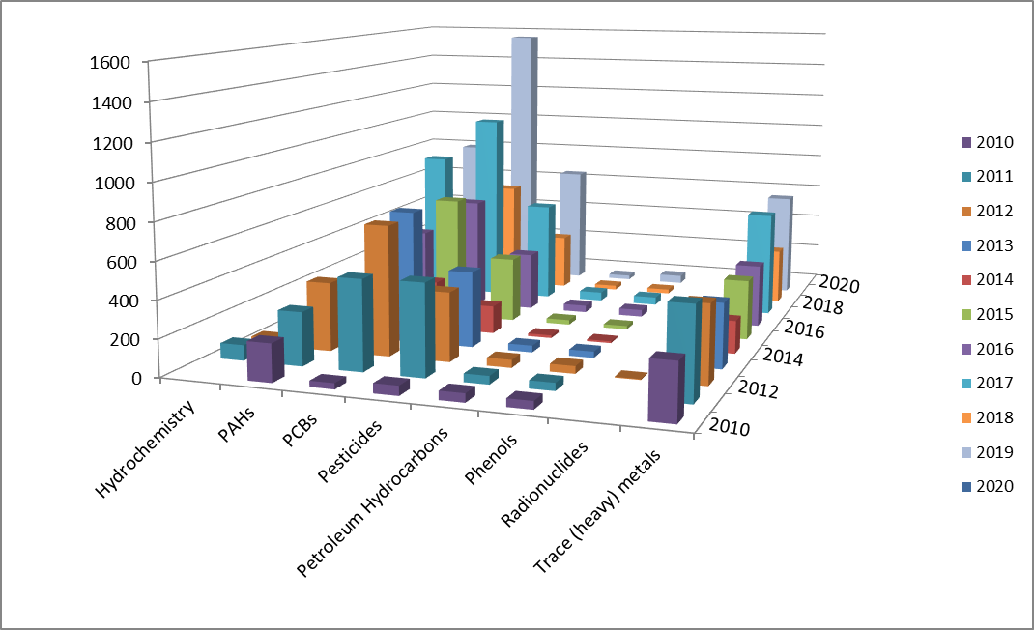
Figure 6.3 - Distribution of the number of samples by parameter groups and years (sediment)

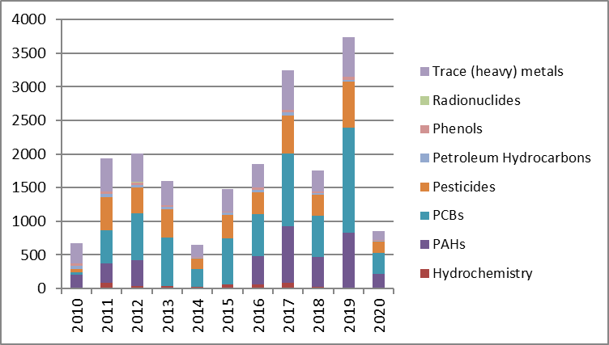
Figure 6.4 - Total number of samples for each parameters group (sediment)

Table 6.5 – Statistics of the number of samples by parameter groups and by years (biota)

Ukraine | SampleType-Biota
ParameterGroup/Year | 2012 | 2013 | 2014 | 2015 | 2016 | 2017 | 2018 | 2019 | 2020
PCBs | 160 | 361 | 320 | 128 | 414 | 529 | 120 | 186 | 234
Pesticides | 88 | 209 | 176 | 69 | 216 | 276 | 48 | 84 | 126
Trace (heavy) metals | 106 | 193 | 176 | 70 | 190 | 242 | 44 | 77 | 121
PAHs |  |  |  |  | 288 | 368 | 64 | 102 | 162

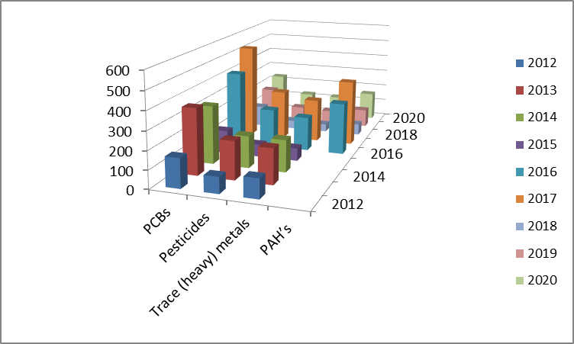
Figure 6.5 - Distribution of the number of samples by parameter groups and years (biota)

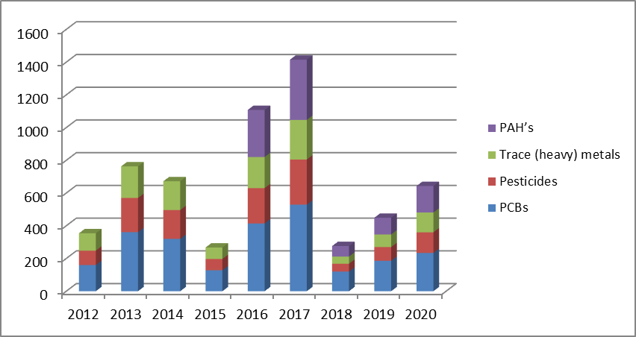
Figure 6.6 - Total number of samples for each parameters group (biota)

